N
E

Oxford Plasmalab System 100 ICP
Standard Operating Procedure

- scope:
The purpose of this document is to provide operating procedures to operate Oxford Plasmalab 100 ICP system for performing a dry etch process for various materials. Equipment specs is also included for better understanding the working range of the tool and help designing more efficient dry etch processes.

- Equipment description:
13.56 MHz powered substrate electrode with separate 13.56 MHz powered Inductively coupled plasma provide separate control of ion, radical density and ion energy to achieve a high etch rate process with superior selectivity of etched material to masking material.

- Equipment configurations:
  - All process gases and corresponding MFC sizes are listed in table 1. Below. Nitrogen and Argon share the same gas line and MFC.

Process Gas | Max. Flow (SCCM)
SF₆ | 100
C₄F₈ | 100
O₂ | 100
Ar | 100
N₂ | 100
BCl₃ | 100
Cl₂ | 100
CH₄ | 100
H₂ | 100
HBr | 100
SiCl₄ | 100
Table 1 available process gases and corresponding MFC size.
  - RF power
    - Maximum substrate electrode power 400 W
    - Maximum ICP power 2500 W
  - Wafer cooling during processing
    - Maximum Helium back side cooling 30 TORR
  - Process table (wafer chuck) cooling
    - Close looped chiller normal setting at 20⁰ C or house chill water at 19 to 20⁰ C

- Wafer etching:

  - System status check
    - Logbook check: Check equipment logbook to see if there is any system failure or abnormality reported on the logbook. Report to staff if there is any and do not use the tool.
    - Vacuum status check: Select “system” menu at left upper corner of the screen then the pumping option. The pump control page will be displayed as shown in Fig. 1

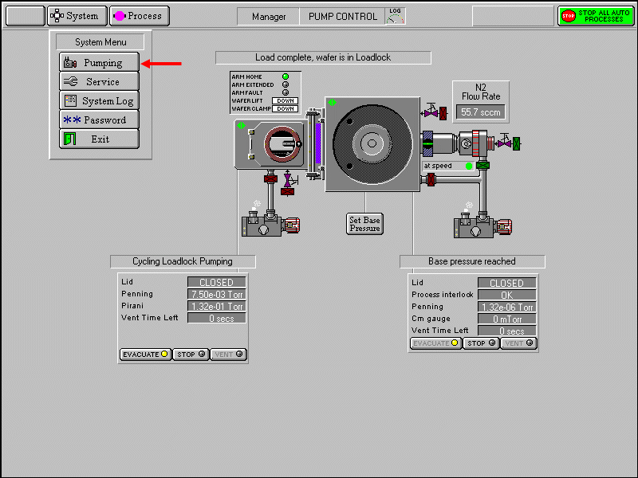
Figure 1 system menu and options

    - On the pump control page. Make sure:
      - Green indicator shows turbo is at correct speed. Chamber penning gauge should show pressure at low E-6 to E-7 TORR range, Process interlock shows OK and load lock penning gauge should show E-3 range.
      - Green ‘ready for transfer’ indicators are displayed on each chamber mimic as seen in Fig. 2 below.

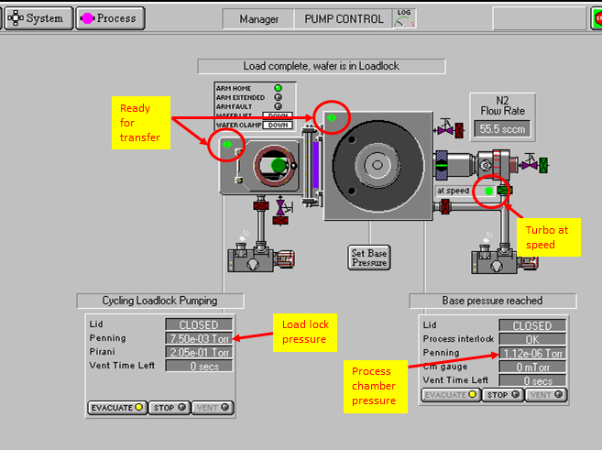
Figure 2 chamber mimics, location of pressure readings and green ready for transfer symbols.

  - Sample preparation
    - If a whole wafer is to be etched and photo resist is used for masking. Edge Bead removal has to be performed to avoid wafer clamp contamination and wafer mishandling.
    - If sample is a partial wafer or small piece of wafer. Adhesive material has to be used to fix the sample to the carrier wafer. Thermal compound, double sided metal tape, fomblin oil, carbon paste, photo resist… can be used as adhesive. Except using photo resist, the rest of the adhesive materials have to be under the sample and not exposed to plasma during etching. Kapton high vacuum tape is prohibited due to possible chamber contamination from by-products produced by plasma etching and possible interference with wafer transfer mechanism. Please consult with staff if help is needed to choose proper method to mount small samples.

  - Wafer loading
    - Click STOP button on load lock chamber then click VENT button. This will start a 200 second vent cycle.
    - Open the load lock lid at end of venting cycle. Place wafer on transfer arm with wafer flat against the two guides as shown in Fig. 3
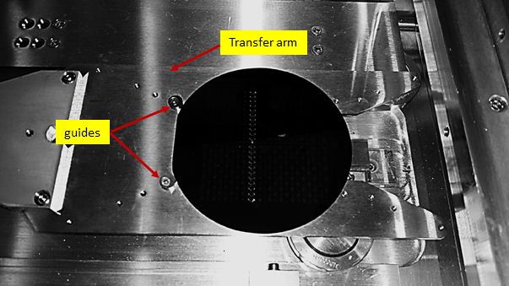
Figure 3 wafer on transfer arm against wafer guide
    - Close load lock lid.
    - Click on load lock STOP button then click EVACUATE button to pump down the load lock. A dialog box will be displayed allowing entry of a wafer name.

  - Wafer processing
    - Wait till green ready for transfer symbol shows on both load lock and process chamber mimic.
    - Click on the PROCESS menu button, three options, RECIPES, LOGVIEW and CHAMBER 1 will show as seen in Fig. 4 below
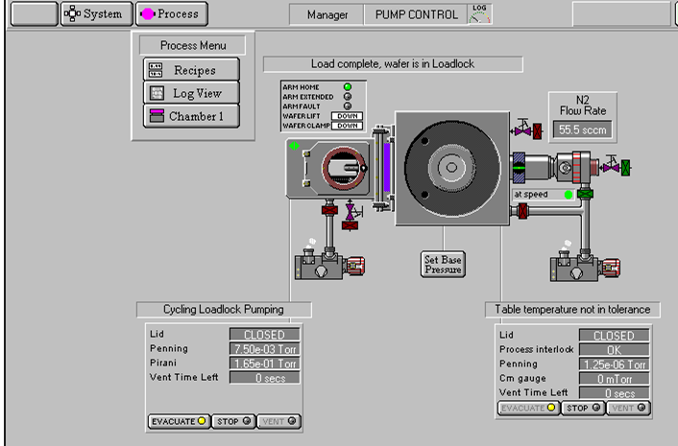
Figure 4 Process menu options
    - Select the RECIPE option to display recipe page as seen in Fig. 5 below.

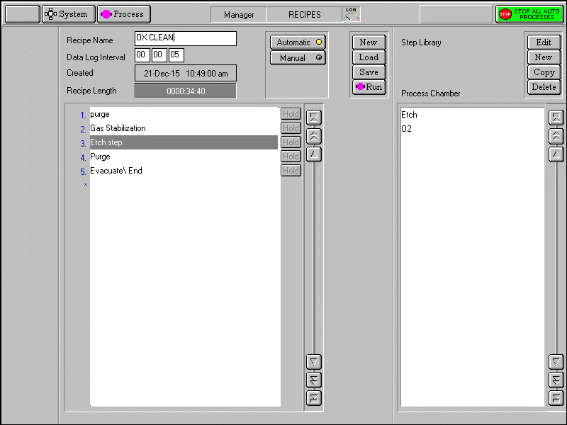
Figure 5 Recipe page
    - Select LOAD from recipe menu, select a recipe from the drop down list which contains all recipes stored in the system in alphabetic order then click OK. See Fig. 6 below. Click OK again when system prompts for over write current recipe?

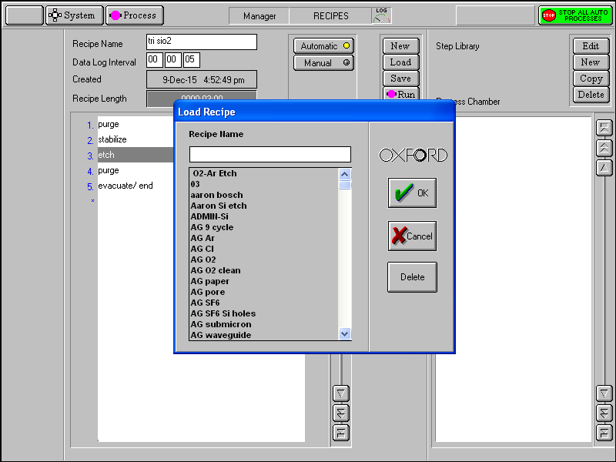
Figure 6 recipe list

    - Click on RUN button. A process control page will show as seen in Fig. 7

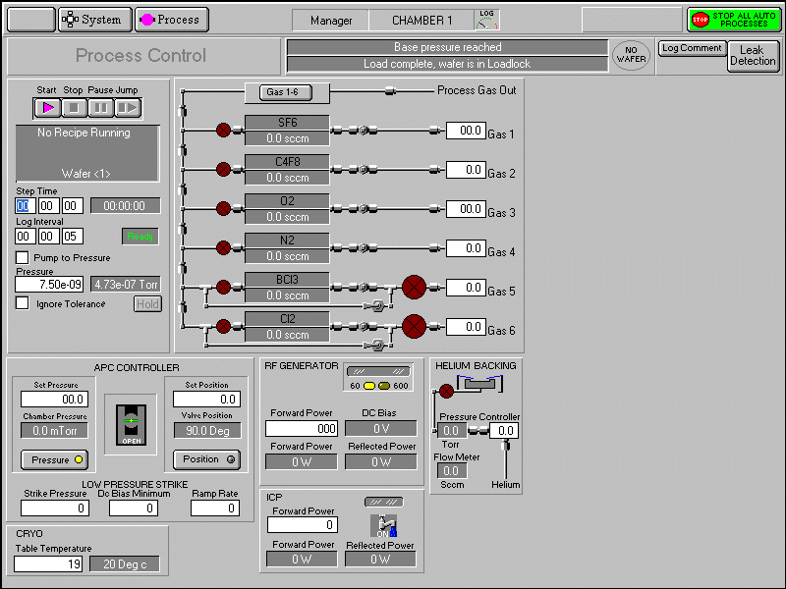
Figure 7 process control page
    - System will automatically transfer wafer from load lock to process chamber, perform all process steps in the recipe then return wafer back to load lock.
    - Once wafer returned to the load lock, click STOP then click VENT.
    - Processed wafer can be removed from load lock after a 200 sec vent cycle completed.
    - Evacuate load lock by closing load lock lid, Click STOP then click EVACUATE to evacuate the load lock.

  - Process control buttons
Four buttons located on upper left corner of the process control page can be used to manually control the process.
    - START: Start a recipe or re-start process after process was paused.
    - STOP: this will stop entire process recipe and wafer will remain in the process chamber.
    - PAUSE: this allow user to stop the step time and plasma power with current step time indicated. Re-starting the process will let the process to continue from the time it was paused. If, during the pause period, you change any of the process parameter, you must press the START button for the changes made to come into effect, this will cause the step timer to continue from the time it was paused. System will continue to next step till all steps have been executed then wafer will be transferred back to load lock.
    - SKIP: this will stop the current process step and execute the next process step.

- Edit/ Create process recipe

  - Edit recipe:
    - Edit an existing recipe step
- Select PROCESS menu then RECIPE option.
- Select LOAD. A drop down list of recipes in alphabetic order is displayed.
- Select desired recipe from the list. Steps of the recipe will be displayed. Click on a recipe step. A step commands pop-up menu will be displayed with following six options. Edit/Repeat Step/Loop Step/Insert Step/Delete/cancel Step See Fig.8 below:

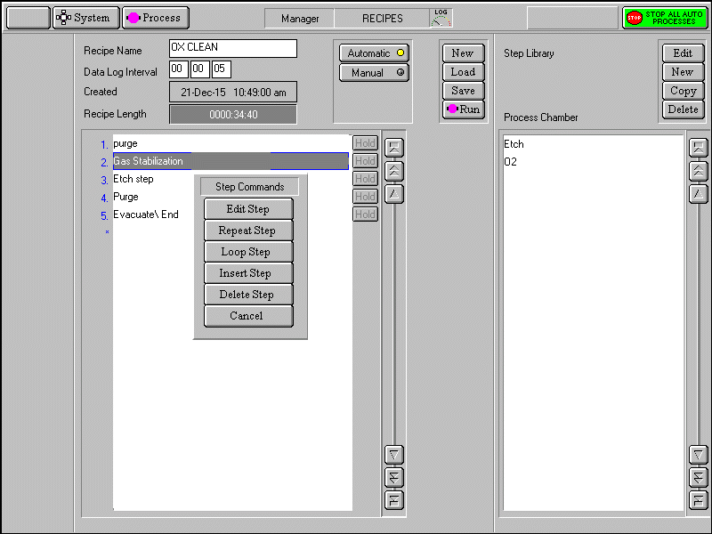
Figure 8 Options for editing an existing process step parameters
      - EDIT to modify parameters in the process step.
      - REPEAT STEP repeats all subsequent steps until a loop step is reached.
      - LOOP STEP terminates a repeat step group
      - INSERT STEP create a gap above the selected step to allow another step to be created.
      - DELETE STEP deletes the selected step from list.
      - CANCEL exit editing option.

  - Create new recipe:
    - In the step library panel, select the NEW button. The step editing page is displayed.
    - Enter desired recipe name then save.
    - Click on the blank panel to show the step commands pop-up menu.
    - Select EDIT to open process page then enter all parameters as required.
    - Repeat above step till all recipe steps are entered and saved.
    - Click SAVE to save recipe.

- Using argon as process gas
The following procedure has to be followed to switch nitrogen to argon to ensure process integrity.
    - Close nitrogen valve by turning the valve handle 90 degrees clockwise.
    - Select PROCESS menu then CHAMBER 1 option. System will display the process control page
    - Check IGNORE TOLERANCE check box on the left side of the process control screen.
    - Set nitrogen flow to 100 SCCM and step time to 5 minutes.
    - Set all other parameters to zero.
    - Click the START button on upper left corner of the screen.
    - Nitrogen will start to flow from 100 SCCM then slowly drop to less than 1 SCCM in 3 min.
    - Reset the nitrogen flow to 0 when step is completed.
    - Open the argon valve on the wall by turning the valve 90 degrees counter clockwise.
Switching argon back to nitrogen (Must be done before you leave the system)
    - Close the argon valve on the wall by turning the valve 90 degrees clockwise.
    - Repeat step II to VII from above.
    - Open nitrogen valve by turning the valve 90 degrees counter clockwise.
Fig 2 below shows argon valve at closed position and nitrogen valve at open position.

Complete the log book information for your run.
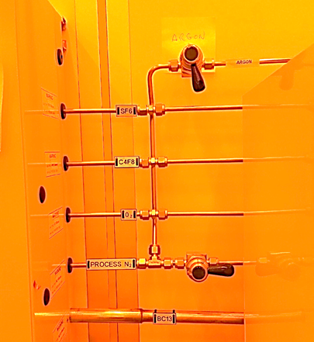
Figure 9 nitrogen valve is open and argon valve is closed.
- Switching from fluorinated gas process to chlorinated gas process

Although both fluorinated and chlorinated gases are available for processing but the ICP system is by default set for fluorinated gas process. If chlorinated gas are needed for processing, inform staff prior to usage to arrange the switch which includes but not limited to RF chamber clean, RF ICP clean, physical chamber clean or kit swap and process chamber conditioning.

