N
E

Center for Nanoscale Science and Engineering

General Safety, Hazardous Chemical and Materials Safety Training Course

University of California, Riverside
Bourns Hall B121
Nanofabricaton Cleanroom

12/1/2017
CNSE Organization
Dr. Alexander Balandin - Director
Mark Heiden - NanoFabrication Laboratory Manager
Staff Members:
Dr. Dong Yan - Senior Development Engineer
Frank Lee - Senior Development Engineer
Dr. John Butler – Assistant Development Engineer

Safety Statement
The CNSE management will conduct its operations in order to provide for the safety of the users and the protection of the equipment. Safe operations will be the first priority in all cleanroom activities.
All users are responsible for safety in their respective experiments and lab equipment usage. No task is so important and no experiment is so urgent that we cannot take the time to perform safely.

Laboratory Overview
The Cleanroom is approximately 2,000 square feet in size with a single work bay that is rated at class 100 and a second bay that is rated class 1,000 for air quality. The processing bays include tools to perform Photo-lithography, Wet and Dry Etching, Dielectric Deposition, Metal Deposition, Film Profile and Device Characterization.

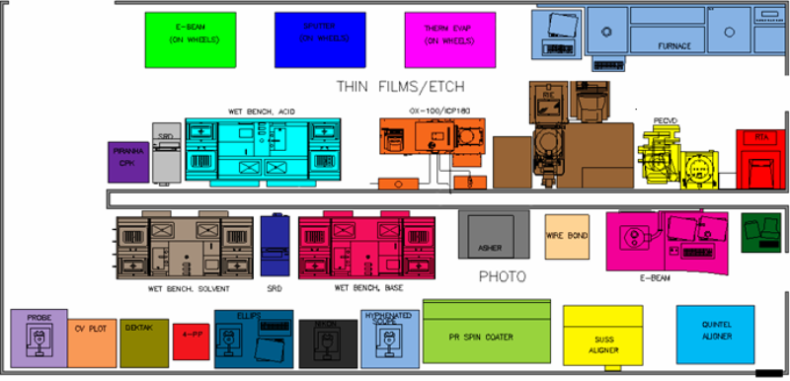
Laboratory Communications
Users are encouraged to make extensive use of email to stay informed regarding changes in the Cleanroom. Your email address will be used to communicate Equipment status, Lab Safety and Protocol announcements.
Staff, Management and Emergency Contact phone numbers are posted in the gowning room and entry hall.
Also, visit www.cnse.ucr.edu to learn about user policies, review training documents and access general information. The online Tool Reservation System, as well as other resources, is also available on the CNSE website.

General Lab Safety and Protocol
Eye Safety
When working inside the cleanroom many tools require the use of Eye protection. Equipment that emits light such as Ultra-violet exposure systems, Plasma Etchers, E-beam Evaporators and other deposition tools require the use of dark protective glasses or goggles. Clear protective safety glasses must be used at all times when working with chemicals. A face shield is required when pouring chemicals.
If there is an accident while you are working inside the cleanroom you may not be the only person affected. Other people working with you in the lab on in the same building, the equipment you are using or the one standing nearby, and the University and the entire Riverside community can be impacted as well.

Other general safety guidelines
- Never work at chemical benches alone.
All cleanroom users are required to follow the “Buddy System”. Whenever working at a wet bench with hazardous chemicals there must be at least two trained users in the room. This applies to after hours and weekends as well.

- Do not use any equipment that you have not been trained on.
You must be fully trained on any equipment prior to operating it.

- Do not operate any equipment in an unsafe condition.
If you perceive there is an unsafe or hazardous condition in the lab, notify staff immediately.

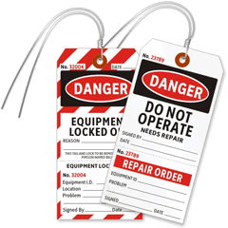
- No open toed shoes or sandals are allowed in the room.
- Lock Out Tag Out
“Lock out Tag out” labels are placed on equipment by staff when the tool is unsafe to operate. Do NOT attempt to power up or use any equipment if a sign is present.

- Warning Signs
Make sure you are aware all signs, postings, emergency equipment and labels in the lab.

- Using hot plates and ultra-sonic baths
When working with hot plates and ultra-sonic baths, make sure you know the flash point for the chemical you are heating. This information is included in the Material Safety Data Sheets for each chemical located in the “Right to Know” center just inside the room.

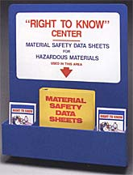

Fire Safety
There are four classes of fire, categorized according to the kind of material that is burning. These sets of color-coded icons are commonly used on most fire extinguishers to indicate the kinds of fires against which the unit is intended to be used. There is only one icon representing Class D fires, because they involve uncommon materials and occur in fairly specialized situations. Note that any given fire can fall into more than one classification.
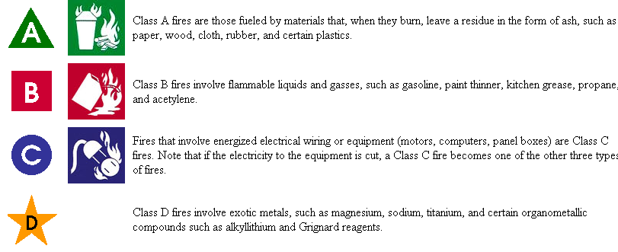
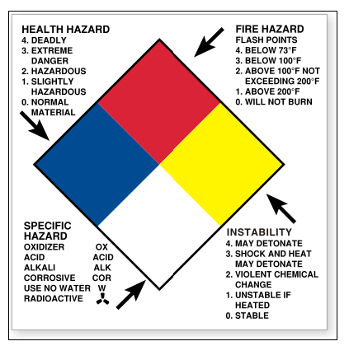
The cleanroom fire extinguishers contain Halon and are most appropriate for the types of fires likely to be encountered inside the space. These extinguishers replace the oxygen in the fire and do not emit large quantities of powder that would destroy the environment.

NFPA Label
Hazardous material containers located inside the cleanroom and service chase areas will have National Fire Protection Agency labels that color code the hazard.

Applicable Safety Agencies & Programs
CNSE cleanroom operations fall under these applicable safety agencies:
Occupation Safety and Health Administration

Environmental Protection Agency

Department of Transportation

UCR’s Environmental Health and Safety

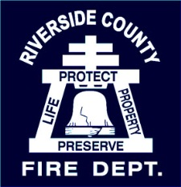
Riverside County Fire Department & HAZMAT team

Handling Hazardous Chemicals
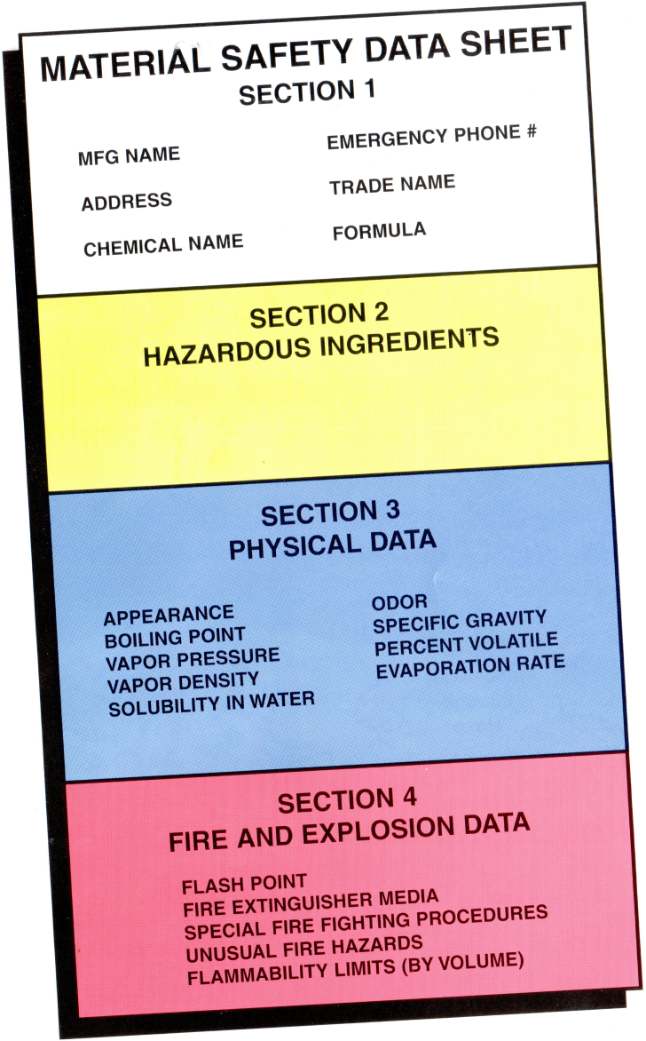
Material Safety Data Sheets (MSDS)
Each chemical that is present in the cleanroom has a Material Safety Data Sheet specific to the chemical. The MSDS is the backbone of hazard communications- it provides details on: chemical ingredients, chemical dangers, emergency response direction and procedures. Before using any chemical, read and understand the MSDS sheet for the chemical. These sheets are available in the “Right to Know” Center just inside the cleanroom door and on the cleanroom website. If you need to bring in your own chemicals, you must provide the MSDS sheets to staff for approval and inclusion in the cleanroom MSDS book first.
Always understand the dangers of the chemicals that you are working with and that are around you in the lab. From reading the MSDS sheets you should know the following:
- Know their flash points and Reactivity.
- Handling and storage requirements.
- Exposure effects\ Health hazards.
- First aid measures.

As well as reviewing the MSDS sheets, the cleanroom requires that each user receive process specific training prior to using hazardous materials or chemicals. This training will include proper usage of Personal Protective Equipment (PPE) such as gloves, safety glasses, chemical aprons etc. Chemicals are only allowed to be poured and used under the appropriate fume hood.

The following must be worn at all times when pouring acids or any other harmful chemicals:
Chemical-resistant gloves Chemical Apron
Nitrile gloves Closed- toe shoes
Face shield

Proper Chemical Usage & Storage
Cleanroom Chemical List
There is a complete inventory list of our chemicals at the hallway entrance. This is only a partial list of chemicals used in the cleanroom:
Sulfuric acid
Nitric acid
Hydrochloric acid
Acetic acid
Acetone
Isopropanol
Hydrogen Peroxide
Ammonium Hydroxide
Ammonium Flouride
Hydroflouric acid
Phosphoric acid
MIBK
Photoresist

You must always get approval from the Nanofabrication Staff before buying or ordering a chemical. Do not show up with chemical in hand and expect instant approval.

Chemical Containers in the Cleanroom

Always use beakers made of the appropriate material for the chemicals and temperature range of the experiment. All containers with chemicals must have a label with the chemical name and owner contact information. Never leave unlabeled containers in the fume hoods. All used chemicals must be disposed of immediately and contaminated materials, such as lint-free wipes or glass, have special zip-loc bags located under the benches for their disposal.

Remember: All chemicals in the cleanroom must be clearly labeled.
Please report missing or illegible labels to cleanroom staff.

Empty Bottle Disposal
All empty bottles should be completely rinsed with water three times and labeled “Rinsed” on the bottle. Do not discard empty chemical bottles, cleanroom staff will dispose of all empties.

Chemicals used in the cleanroom must be used inside the four separate wet benches provided. Each bench must ONLY be used for the specific chemicals designated in order to prevent dangerous chemical reactions, injury or fire.
Solvent Development & Resist Spin Coating Benches
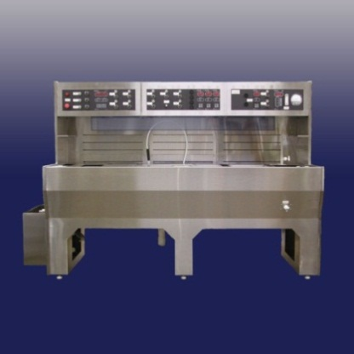
These 2 stainless steel wet benches are for use with solvents and resists ONLY.
NO acids or bases are allowed on these benches.

Plastic Wet Benches

The white plastic wet benches are designated separately, one for use with acids ONLY and the other with base chemicals ONLY.
NO solvents or squirt bottles should be used at these benches at any time.

Handling Solvents
The stainless steel solvent bench is equipped with two sumps to pour waste solvent into. ALL solvents should be disposed in those sumps. NO water, acids or base chemicals may be poured into these sumps. If the sumps do not drain or become full, call the cleanroom staff; do not attempt to clean the sumps yourself.
Also, never use or leave solvent squirt bottles on the Acid or Base wet benches. Never fill a squirt bottle with and Acid or Base chemical.

Handling Acids and Bases
If you are diluting strong acids, add the acid to the water rather than pouring water into the acid.
When disposing of acids inside the cleanroom, slowly pour them down the sink in the acid bench or use the aspirator tubes inside the bench. The process for disposing of bases is the same, except it is followed in the base bench ONLY.

Remember: Always wash your hands after handling chemicals.

Chemical Safety Checklist
Before using any chemicals in the cleanroom you should ALWAYS:

- Read and understand the MSDS sheets
- Get trained by staff
- Put on PPE

Emergency Safety Equipment & Procedures
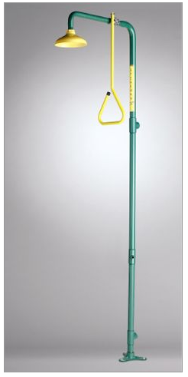
Each person handling hazardous chemicals in the laboratory shall know the location of the following safety equipment:

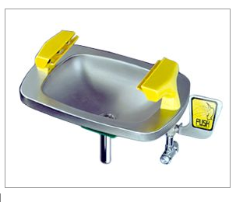
- Emergency showers
- Fire extinguishers
- Eye wash stations
- Telephones
- First aid kit
- Fire pull stations
- Spill kits
- Emergency exits

In case of an emergency: dial 911 from a campus phone.

Chemical Spills
The cleanroom is equipped with a chemical spill kit to contain small spills on the floor. In case of a small chemical spill use the kit and call the cleanroom staff immediately. Use the spill kit on all liquids except Hydrofluoric Acid.

If you are exposed to chemicals on the skin…
- Remove any clothing covering the area.
- Wash in the safety shower.
- Cover yourself with blanket
- Call for help.

If chemicals are splashed into your eyes…
- Rinse your eyes in the eye wash station for 15 minutes.
- Call for help.

For large chemical spills, evacuate the area immediately & notify staff.
Call 911 if the cleanroom staff is not available.
Handling Hydrofluoric Acid
Hydroflouric acid (HF) is one of the strongest inorganic acids and one of the most DANGEROUS acids to work with. Double chemical resistance gloves are always required over standard nitrile gloves. Always inspect the chemical gloves before using for cracks or pinholes!
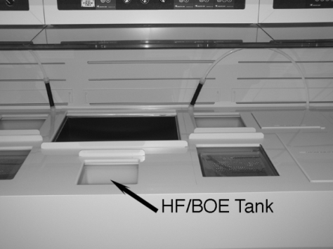

There is one tank in the acid bench dedicated for HF or BOE (Buffered Oxide Etch). You may also use plastic beakers for HF but never glass or Pyrex as the container will be dissolved by the acid.

Personal Protective Equipment (PPE) must be worn whenever an experiment involves HF or BOE etchant; this includes:
- Face shield
- Rubber or plastic chemical apron
- Heavy, long sleeved neoprene or tri-polymer gloves OVER nitrile exam gloves
- Long pants
- Closed toe shoes
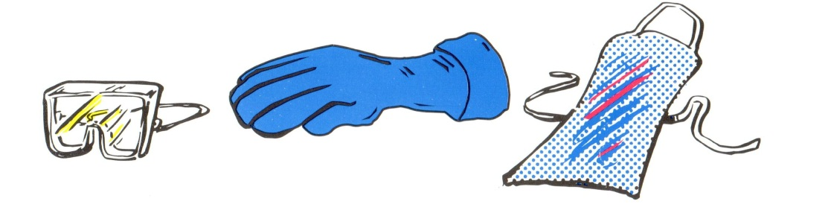

Exposure to Hydrofluoric Acid (HF)

An HF or BOE burn can be very severe and even cause death. The acid attacks bone material by reacting with calcium in the bone. Most organs including the heart can be affected by the disruption of calcium ions. In dilute concentrations, HF or BOE exposure may not cause any pain initially, but is easily absorbed through the skin to attack bone and other tissue.
All HF burn victims must always get medical treatment

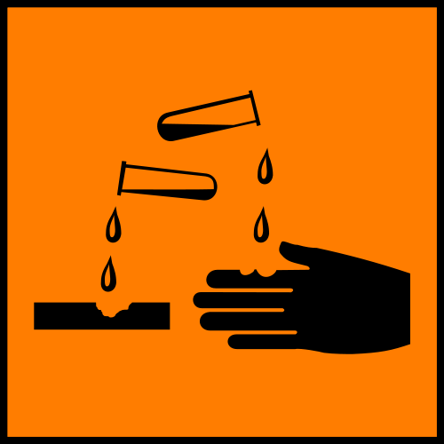
What do in case of exposure to Hydrofluoric Acid?
If splashed…
1. YELL FOR HELP! – Stay calm.
2. Go IMMEDIATELY to a shower (or sink) and wash contaminated area with water.
3. Remove contaminated clothing while washing.
Dial 911 at this point!

4. Wash until all acid is removed from surface, but limit washing to 5 minutes.
5. Dry area quickly and use Calcium Gluconate gel. Apply gel liberally to the affected area and massage into skin.
(Do this until medical help arrives.)
6. If HF is under nails, try to scrub the Calcium Gluconate underneath

If splashed in eyes…
Hold eyes open and rinse in eyewash until help arrives.
Do NOT use Calcium gluconate gel in the eyes.

If inhaled…
Get victim to fresh air.
If a first responder is there they should administer oxygen.

Handling Hazardous Gases
The cleanroom is equipped with many hazardous gasses, some of which require that they be kept in a special automated safety cabinet.

Silane Sih₄
SiH₂ Cl₂
BCL₃
HBR
CL₂
SiCl₄
CHF₃
CH₄
SF₆
N₂O
NH₃
O₂
H₂
CF₄

The individual gas characteristics determine how the gas is handled, used and stored. The gases listed above are toxic, flammable, combustible and/ or corrosive. All toxic and explosive gases utilize double containment stainless steel delivery lines and fire suppression.

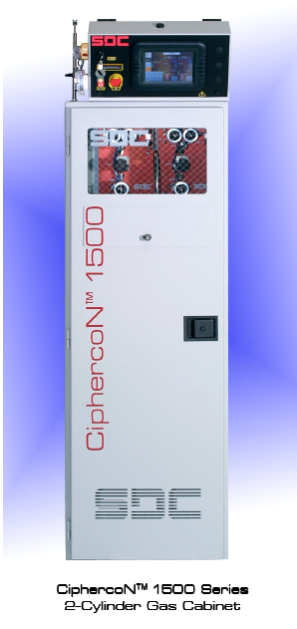
Typical Automated Cabinet
The automated gas cabinets are connected to the facility automated gas detection system. In case of excess gas flow, leak or earthquake the alarm will activate and shut off gas flow to the tools. The process gas lines are double contained coaxial lines and leak tested. Gas cylinders are changed out with an automated touch screen and only cleanroom staff is permitted to change them. If any alarm sounds or if a process fails due to inadequate gas delivery, please notify staff immediately.
The safety features on cleanroom tools may not be overridden, including the hazardous gas cabinet safety features. The toxic gas alarm system must remain activated at all times. All process recipes must be approved by staff. Never operate a tool with hazardous gas in an improper manner. If a gas cabinet alarms, call staff immediately.

Alarms and Emergency Evacuation
The cleanroom toxic gas alarm sounds with a loud siren and green flashing strobe light. If this alarm sounds, exit the lab immediately.
The building fire alarm sounds with a high-pitch chirping sound and a white flashing strobe light. If this alarm sounds, exit the lab immediately and proceed outside to the quad area.
Always contact staff at the phone numbers posted outside the lab, if one of these alarms sounds.
Local alarms require different actions:
Wet bench alarms will have a solid audible tone. Go to the bench and silence or reset the alarm and call staff only if necessary.
Tool alarms typically have an audible intermittent tone. Go to the tool and silence or reset the alarm and call staff only if necessary.
Gas cabinet alarms have a solid loud high pitch tone. Do not approach the gas cabinets and call staff immediately. Gas scrubber alarms are also a solid audible tone— for these alarms also contact staff.

