N
E

Filmetrics ProFilm 3D Optical Profiler
Operation Manual

- Scope:
The purpose of this document is to provide operating procedures for using the Filmetrics Profilm 3D optical, non-contact surface profiler to construct a 3D sample image and perform surface roughness, topography and step height measurements in the range of 0.1 nm to 10 mm

Limitations: The Profilm3D measures reflective materials very accurately. Transparent materials may require use of the Filmetrics F40 tool.

- Ensure the following before using the tool:
  - No fault or abnormal condition of the tool has been reported on the user log sheet.
  - The two blue LEDs are on (on front panel of the Accurion vibration isolation table controller located underneath the computer table).

- Step height measurement:
  - Area to area step height measurement:
    - Place sample on center of stage, click “Live” on upper left corner of screen.
    - Use the functions in “Focus” window to bring sample surface into focus.
    - Use the functions in “X-Y Stage” window to move stage to desired measurement location.
    - Use “Zoom” in “Acquisition Settings” window to change the zoom setting. For 10X objective, the scan area for 1X is 2000 X 1700 um, 2X is 1100 X 850 um and is 600 X 450 um for 4X.
    - Once sample is in focus, interference fringes should be visible on the camera screen.
    - Level the stage by turning the Tilt adjustment knob, located in the front of the stage, either clockwise or counter clockwise until the fringes on screen are aligned perfectly vertical on the screen as shown in Fig. 1.
    - Turn the Tip adjustment knob, located at right side of the stage, in the opposite direction used in the previous step until only 1 or 2 interference fringes are visible on the camera screen as shown in Fig. 2. Re-focus as needed after each adjustment of Tilt/Tip.

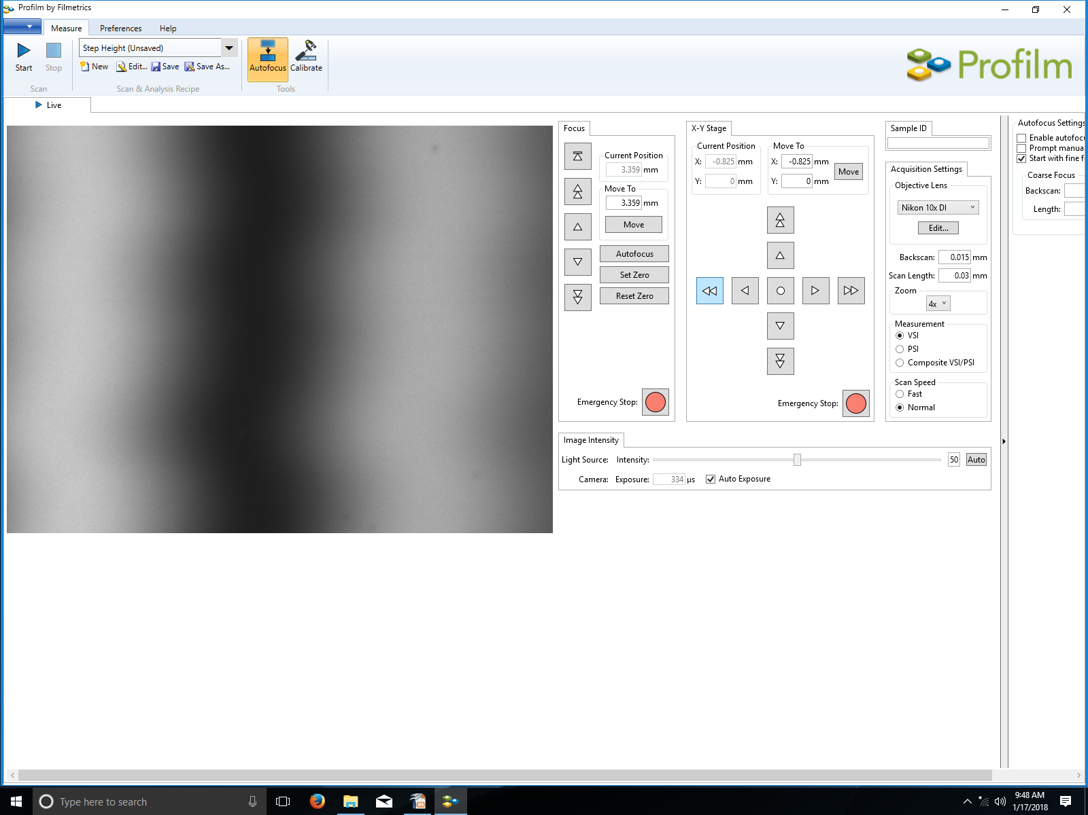
Fig.1 Interference fringes Fig.2 Interference fringes, sample flat

    - Click “Start” at upper left of the live window to perform the surface scan.
    - After the scan is completed. System will automatically detect the step edge and place proper sized measurement rectangle on either side of the step edge and display the step height result at bottom of the “Step Height Measurement” window at right hand side of the screen as shown in Fig.3.
    - To change the view angle of the 3-D image just click and drag on the image to change angle until reach desired angle.
Fig.9 measurement area selection
Fig.3 Automatic measurement result Fig.4 Sample leveling

  - Refine step height measurement:
    - Click “Go back to step 1” in “Step Height Measurement” window.
    - Select “Level” 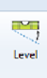 on top of the menu bar.
    - Drag and place the three circles as far apart as possible on a known level surface. Click “OK” to preform sample leveling as shown in Fig. 5.
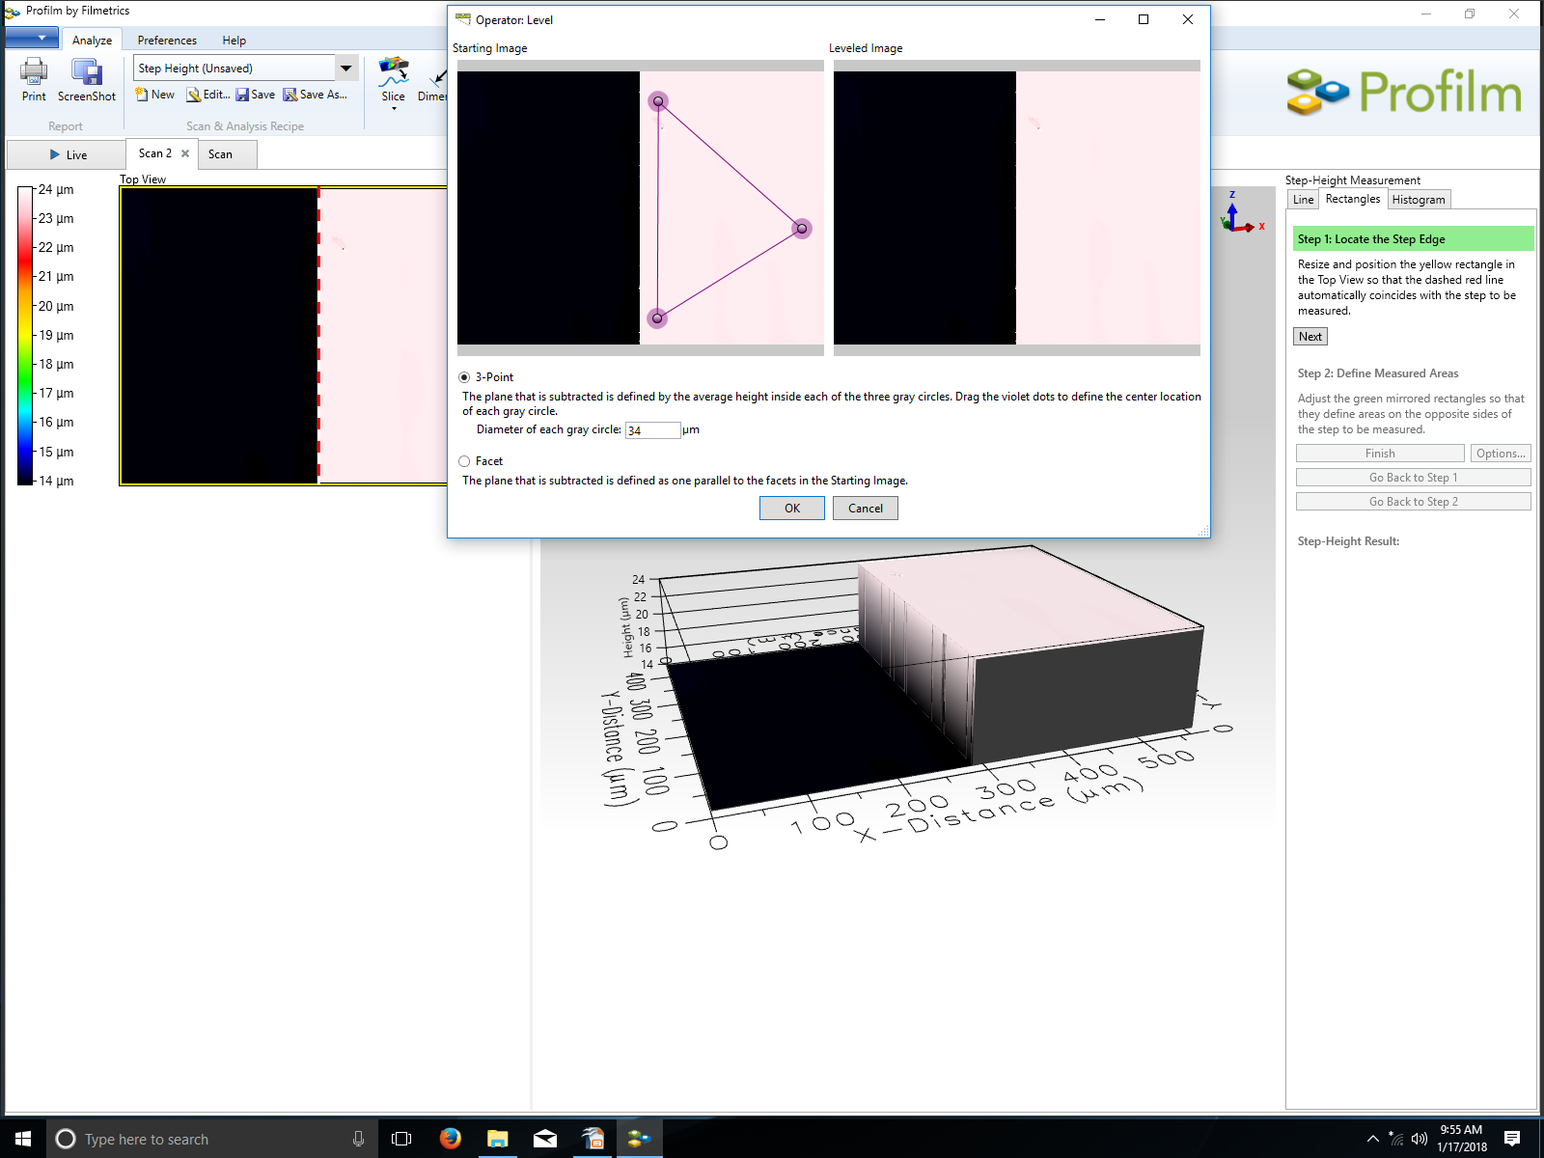
Fig.5 Sample leveling
    - Click and drag sides of the yellow rectangle to resize. Click inside the rectangle and drag to change the location of the rectangle so the red dotted line coincide with the step edge as shown in Fig. 6.
Fig.6 Redefine step edge Fig.7 Redefine step height measurement
    - Click “Next”. Two green measurement area rectangles will show on each side of the step edge.
    - Click and drag sides of the green rectangle to resize and click inside the rectangle area and drag to relocate the rectangle to desired measurement site as shown in Fig. 7.
    - Click “Finish” to measure step height.

  - Line Segment Height Comparison:
    - Click “Line” on top of “Step Height Measurement” window at right hand side of screen.
    - Click and drag the red line in “Top View” window up or down to change cross section location horizontally.
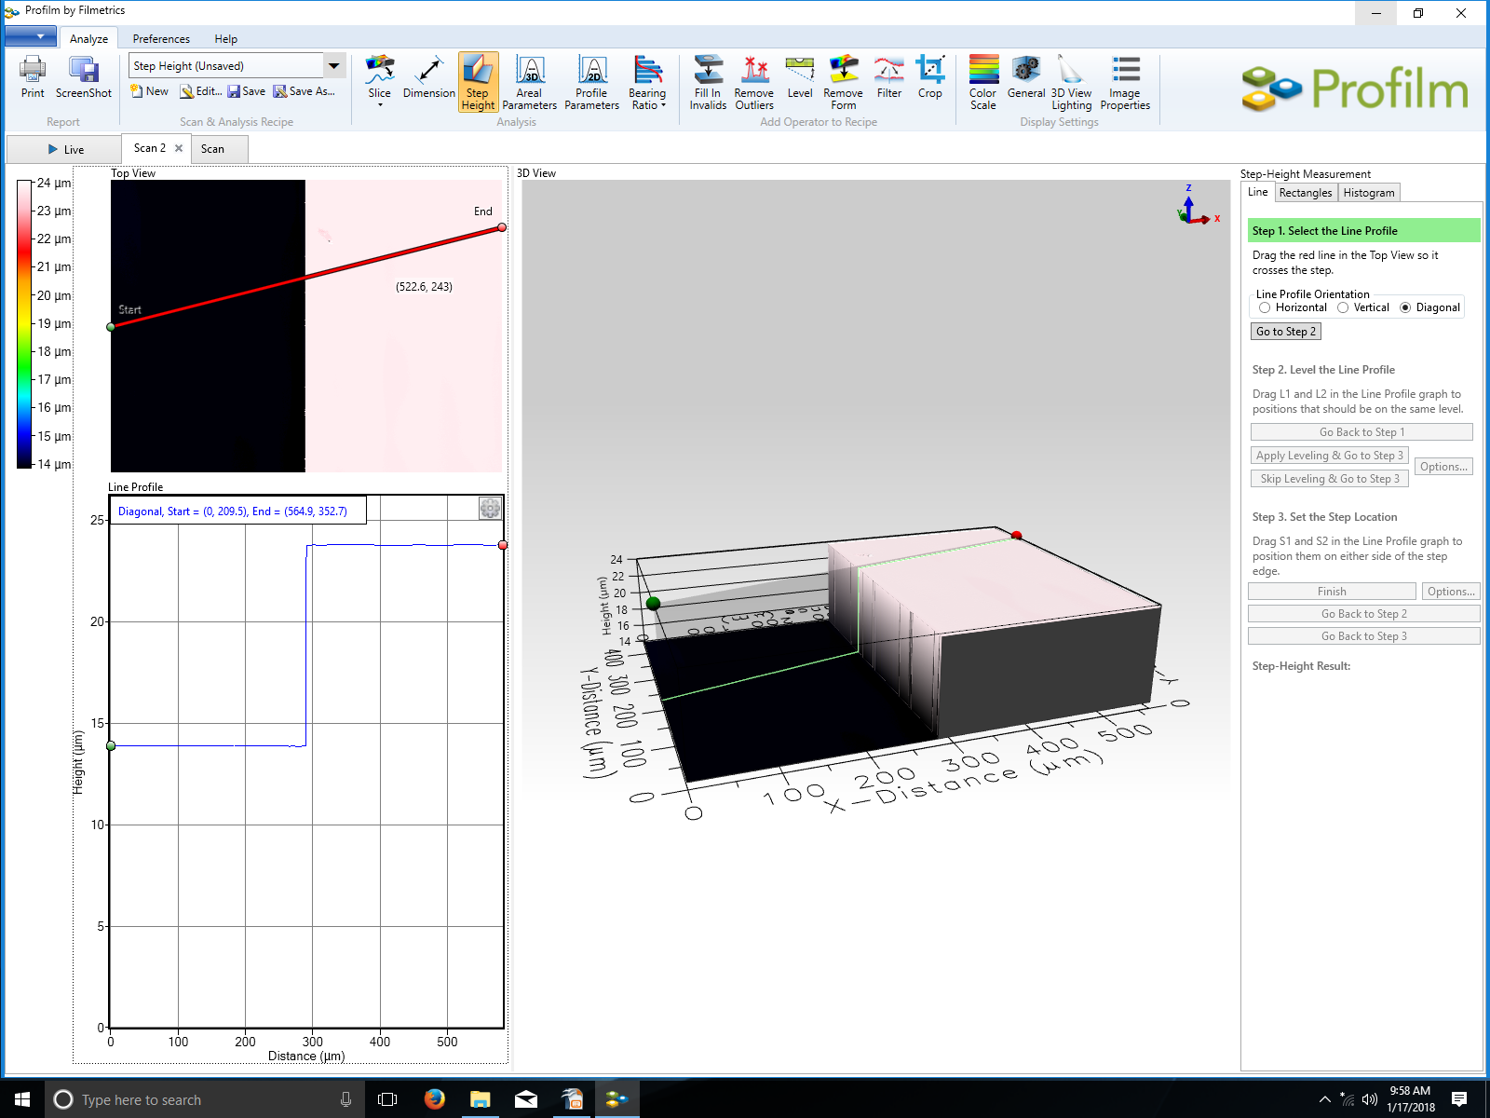
Fig.8 Cross section location change (horizontally) Fig.9 Cross section location change (diagonally)
    - Click “go to step 2” and drag L1 and L2 in the Line Profile Graph to position that should be on the same level and as far apart as possible as shown in Fig. 10.
    - Click “Apply leveling & Go to Step 3”.
    - Drag S1 and S2 lines in the Line Profile Graph to position them on either side of the step edge.
    - Click “Finish” to measure the step height between the two lines. See Fig.11.
    - The width of L1, L2, S1, S2 can be changed by clicking the “option” button and enter desired number in microns. The default value is 6 microns.
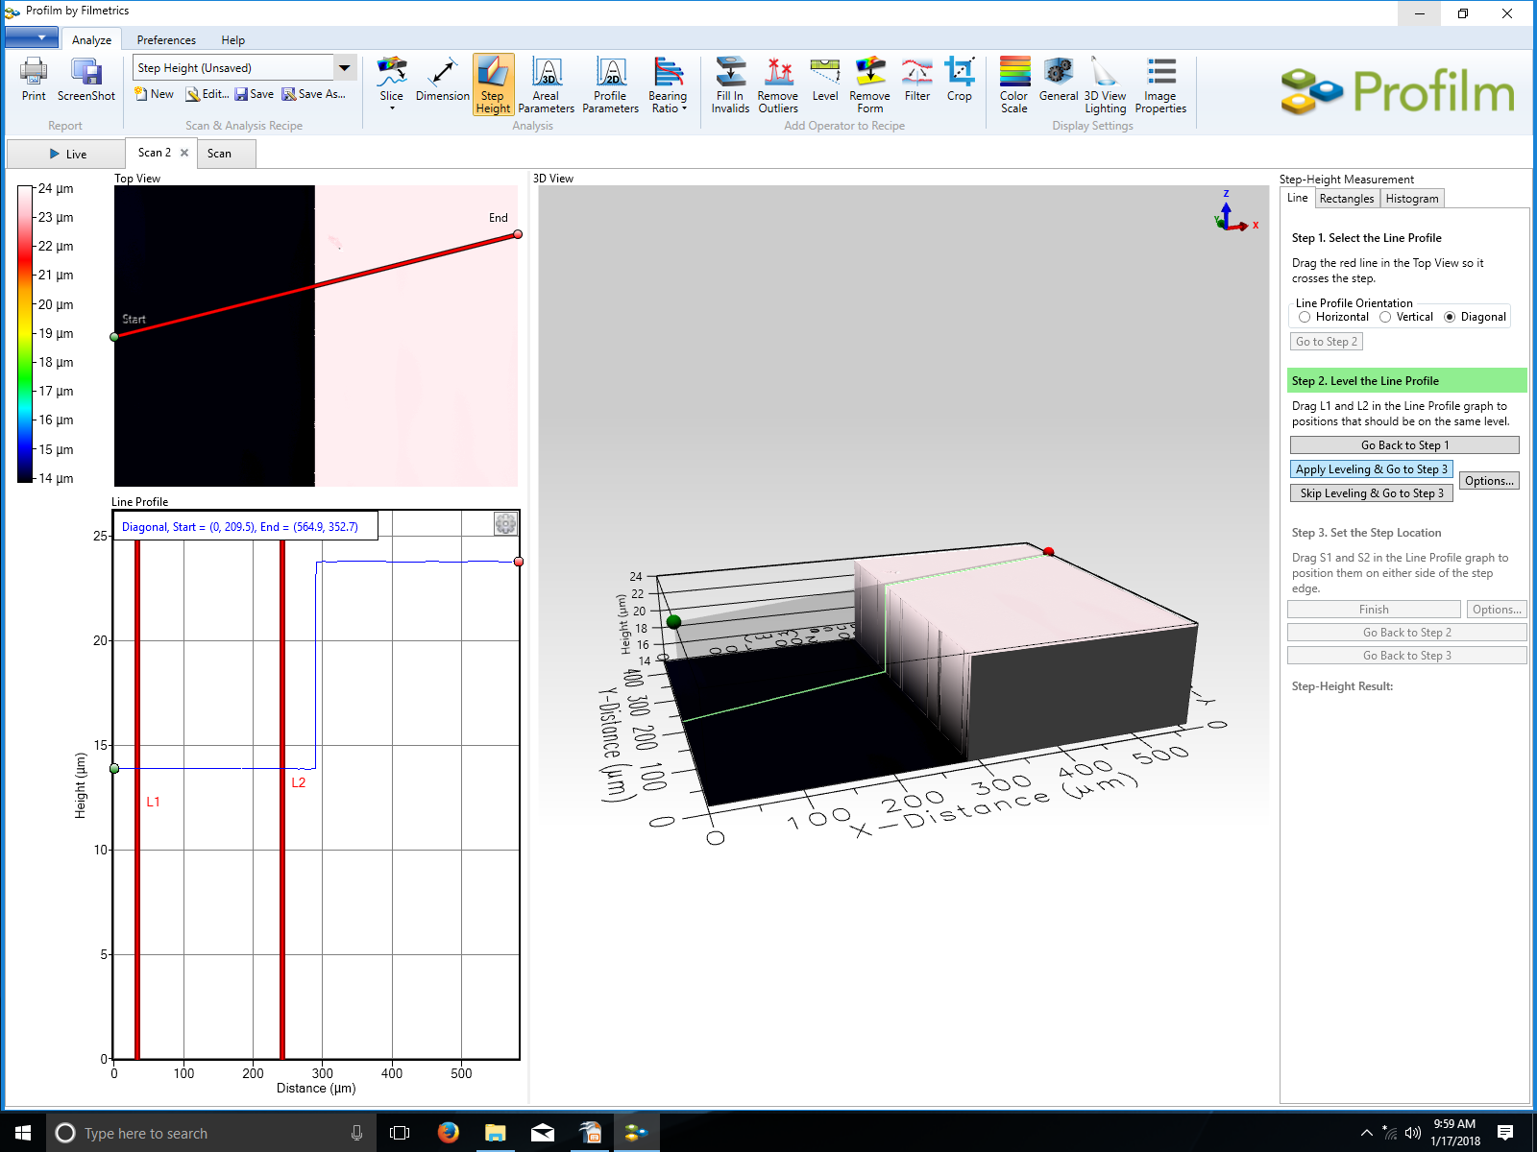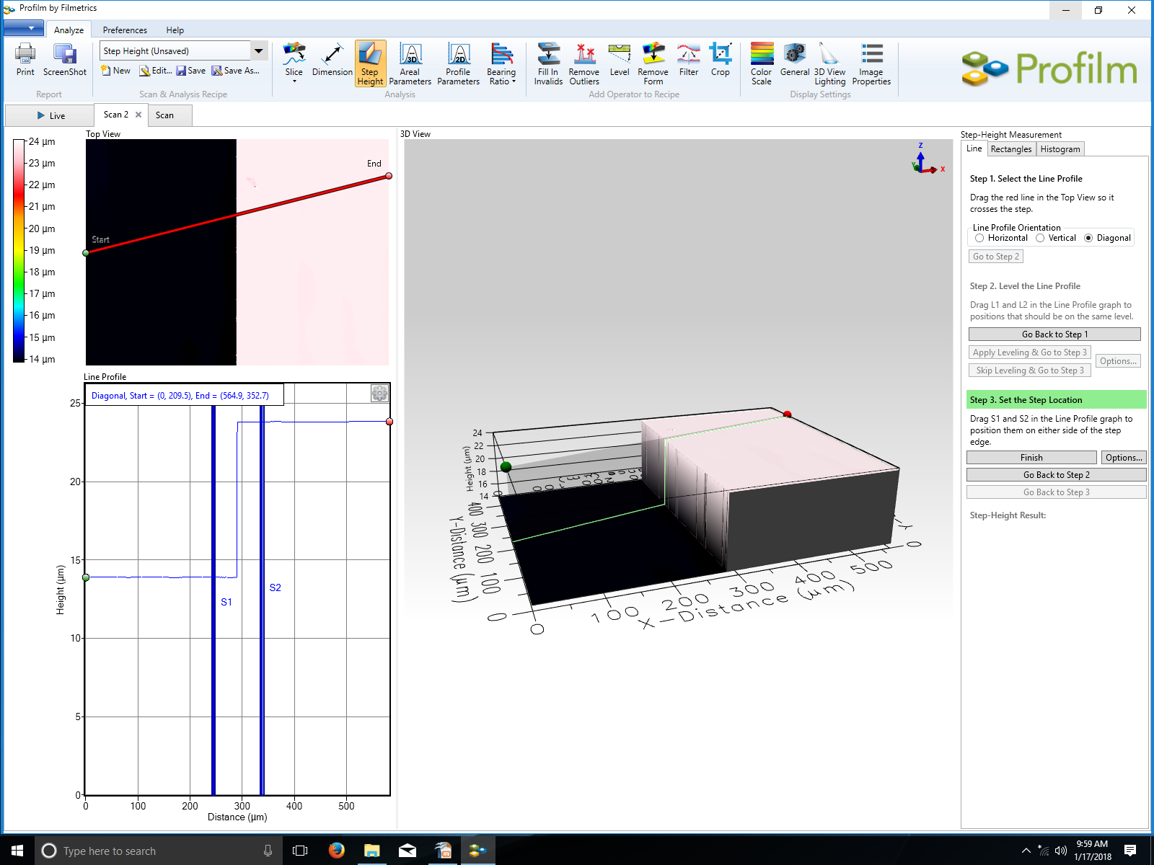
Fig.10 Line measurement sample leveling Fig.11 Step height by line segment

- Area surface roughness measurement:
  - After automatic step height measurement. Click “Areal Parameters” on top menu bar. All areal parameters will show in “Measurement” window at right side of the screen.
  - Select “Restricted area” under “Area of interest” sub window.
  - Resize and relocate the yellow rectangle to area of interest. Surface roughness along with other surface parameters will show on the right hand side of screen as shown in Fig. 12.
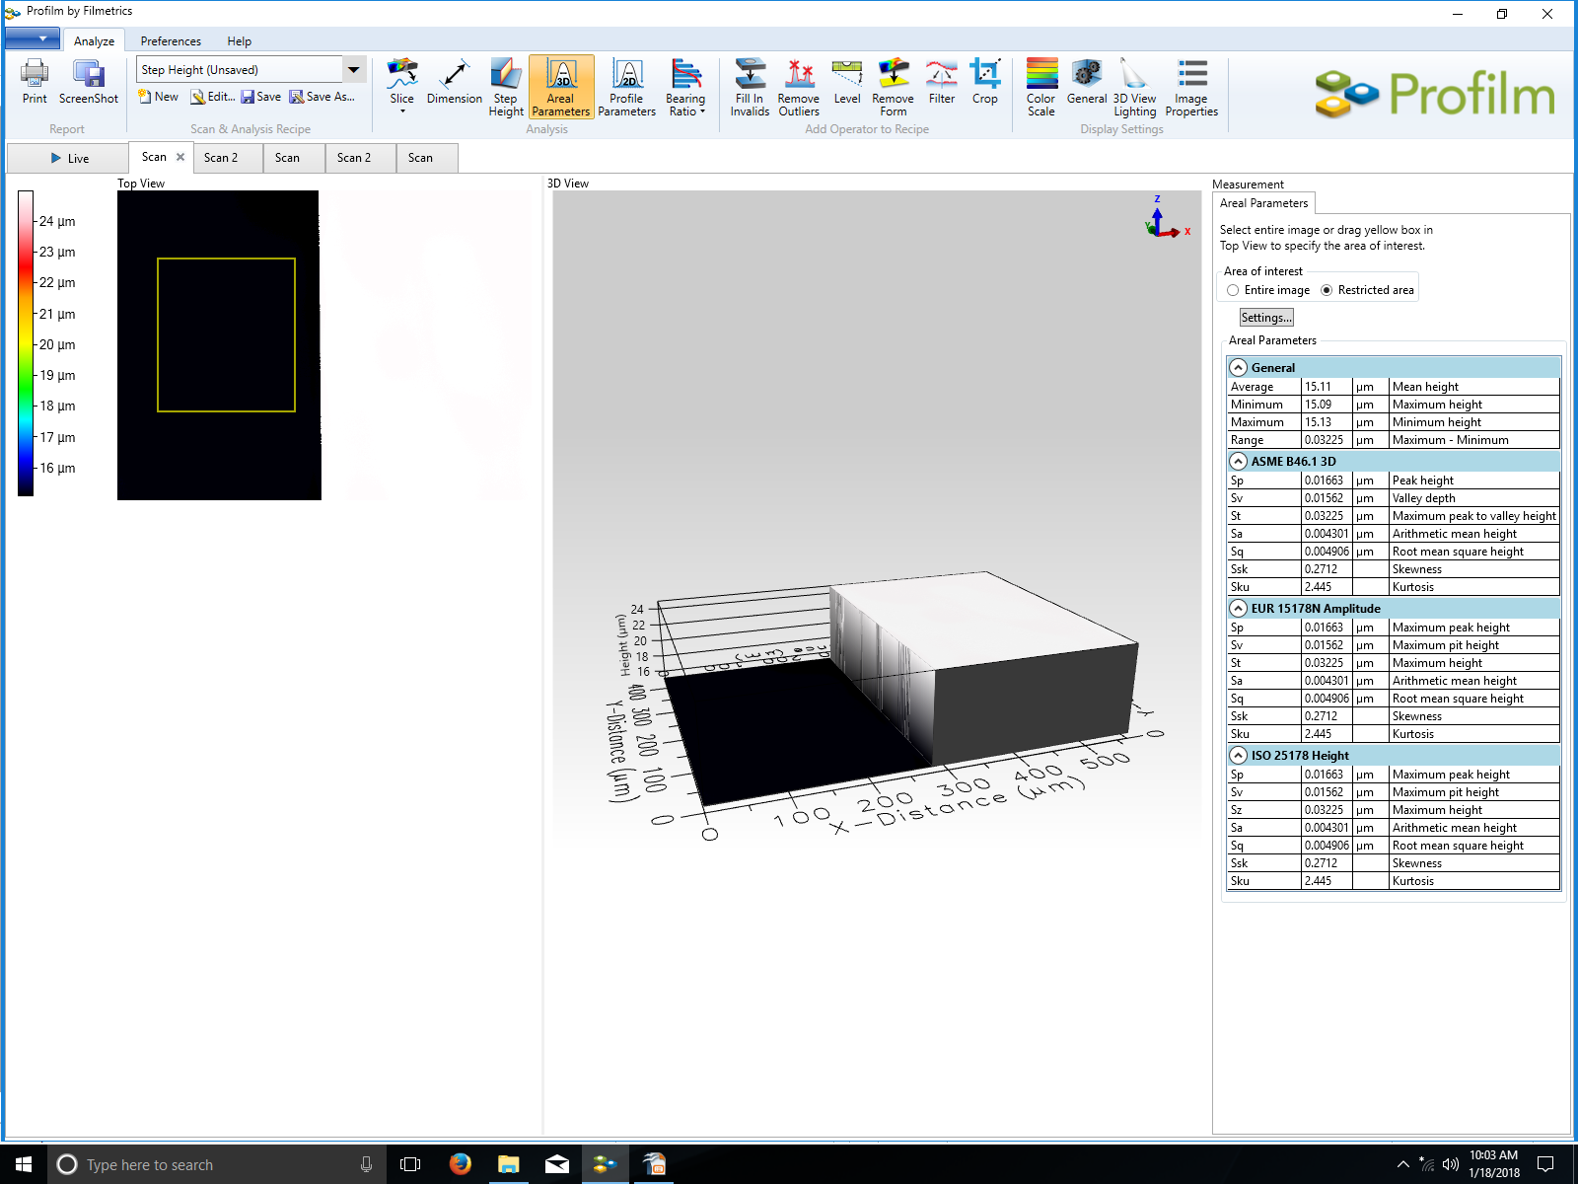
Fig.12 Areal parameters

- Dimensional measurements
  - Line segment measurements
    - Click “Dimension” on top menu bar select “Add Line”. A new line with two green circular end added to the “Top View”. Click and drag each of the green ends to match the segment of interest. Measurement results will show in “Measurement” Window as shown in Fig. 13.
  - Circular measurements
    - Select “Add Circle”. A circle with two green dots placed at center of the “Top View”. Click and drag the center green dot to move the circle, click and drag the outer green dot to resize the circle. The diameter of the circle will show in “Measurement” window as shown in Fig. 14.
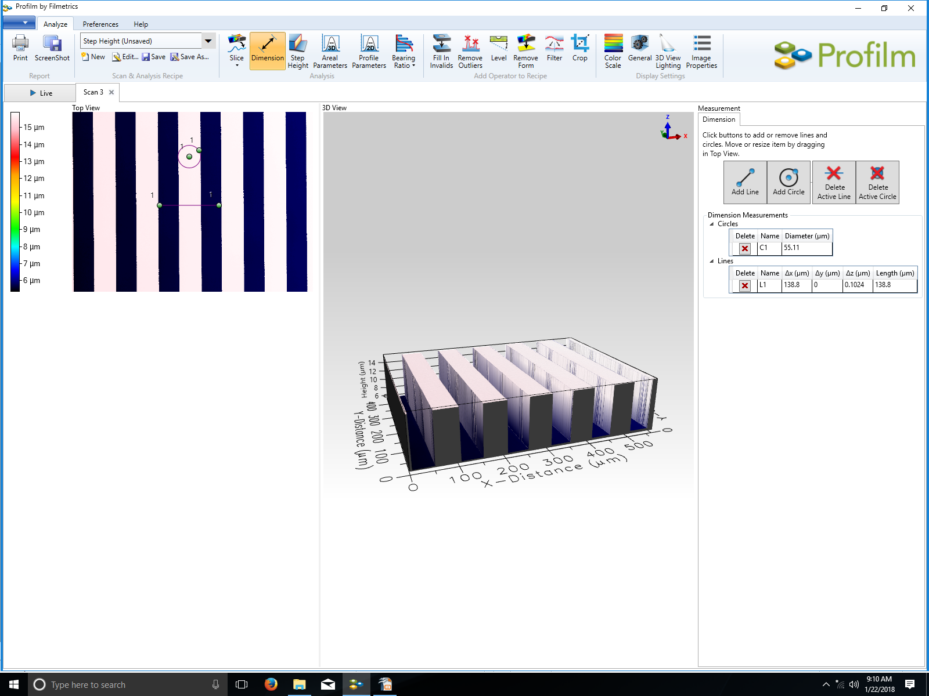
Fig.13 Line measurement Fig.14. Circle diameter measurement

- After measuring, remove your sample from the stage carefully and leave the system as is. Do not turn off software or computer.

