Temescal Sputtering System
Procedure Manual

Table of Contents
Table of Figures 2
1.0 Scope 3
2.0 Applicable Documents 3
3.0 Materials and Equipment 3
4.0 General 3
5.0 Operation 5
6.0 Pump Down 10
7.0 Recipes 11
8.0 Saving/Retrieving Recipes 16
9.0 Automatic Process 17
10.0 Manual Process – DC Power Only 19
11.0 Manual Process – RF Power 24

Table of Figures
Figure 1: Emergency Shut Off 4
Figure 2: Engineering Tab 5
Figure 3: Sputtering Gun locations inside the chamber 6
Figure 4: Threaded Anode/Dark Space Ring 6
Figure 5: Threaded Target Clamping Ring 7
Figure 6: Cathode Body 7
Figure 7: "Config - General" Tab 8
Figure 8: "Config - Material" Tab 8
Figure 9: Sample Holder 9
Figure 10: "Recipe - Skip" Tab 11
Figure 11: "Recipe - Etch" Tab 12
Figure 12: "Recipe - Deposition" Tab 13
Figure 13: "Recipe - Delay" Tab 14
Figure 14: "Recipe - End" Tab 15
Figure 15: "Recipe" Tab - "Load Recipe from Disk" 17
Figure 16: "Download a Recipe" 18
Figure 17: "Engineer Tab" - "Target" Button 19
Figure 18: "Target Selection" - Pop-Up Window 20
Figure 19: "Engineer Tab" - Manual Process #1 (DC) 20
Figure 20: "Engineer Tab" - Manual Process #2 (DC) 21
Figure 21: "Engineer Tab" - Manual Process #3 (DC) 22
Figure 22: "Engineer Tab" - Manual Process #4 (DC) 23
Figure 23: "Engineer Tab" - "Target" Button 24
Figure 24: "Target Selection" - Pop-Up Window 25
Figure 25: "Engineer Tab" - Manual Process #1 (RF) 25
Figure 26: "Engineer Tab" - Manual Process #2 (RF) 26
Figure 27: "Engineer Tab" - Manual Process #3 (RF) 27
Figure 28: "Engineer Tab" - Manual Process #4 28

1.0 Scope
This document establishes the procedures for e-beam evaporated deposition of thin metal films on silicon, GaAs, and other substrates in the Nanofabrication Laboratory.

2.0 Applicable Documents
Sputtering Logbook
System Component Operation Manuals
Sputtering Targets Rates List

3.0 Materials and Equipment
Temescal Sputtering System
Tweezers
Isopropyl Alcohol
Gloves, cleanroom
Cleanroom wipes
Dark glasses, any welder’s lens (shade#6 or greater)
Microscope slides Fisher #12-550C
1/16” Allen/Hex Key
Stopwatch

4.0 General

4.1 The Temescal sputtering system is configured with 3 Angstrom Sciences Onyx 2” magnetrons, two of which can run simultaneously, one on DC power and one on RF power.

The following materials are provided as standard for the sputtering system:

Al | Co | CoFeB | Cr
Cu | Mo | Ni | NiFe
Pd | Pt | Ta | Ti

Deposition parameters and rates for each of these materials are available on the CNSE website.

If other materials are to be sputtered, you must contact lab staff and get permission to set up the recipe first.

4.2 Vacuum Integrity Maintenance. Maintaining a low background pressure is necessary to deposit quality thin films. To avoid contamination, these practices are to be followed:

4.2.1. Never touch any part(s) inside the chamber or part(s) going into the chamber with bare hands or contaminated gloves.

4.2.2 Handle chamber fixtures and parts going into the chamber with gloves and/or vacuum system tools.

4.2.3 Avoid unnecessary touching/handling of chamber parts and vacuum system tool, even with gloves on.

4.2.4 Clean any area or tool that will contact vacuum chamber parts by wiping with lint-free wipes and isopropyl alcohol.

4.2.5 Do not use any material in the evaporator that has not been approved by the NanoFab engineer responsible for this system. This includes tape, plastic, or any custom wafer holders.

4.2.6 The vacuum chamber should not be subjected to atmosphere for excessive periods; pre-deposition preparation should be done in a timely manner to avoid such exposure.

4.2.7 A cleanroom mask must be worn while the chamber is open.

4.2.8 Use vacuum designated tools, provided at the station, only for their intended use.

4.2.9 Load only clean substrates and clean substrate holder/fixtures into the vacuum chamber.

4.3 Emergency Shut Off: The red emergency button is located in the middle of the front panel. This will shut down the whole system and should only be used in an emergency situation. (Fig. 1)

Figure 1: Emergency Shut Off

The Temescal Sputtering System shares the same user interface with the Filament evaporator and E-Beam Evaporator therefore the vacuum system operations described in this document are universal. Recipe parameters, starting pressures, vent sequences are different and this document is specific to the Sputtering System.

5.0 Operation

5.1 Check log book to see if the last user reported any problems. Contact staff if a resolution to the problem has not been logged.

5.2 Login: You will login by swiping your swipe card through the reader attached to the system

5.3 Loading:

5.3.1 Turn on the N2 vent gas by turning the valve counterclockwise on the N2 tank mounted behind the system.

5.3.2 Press “Engineering” button on top of screen to bring up system graphic.

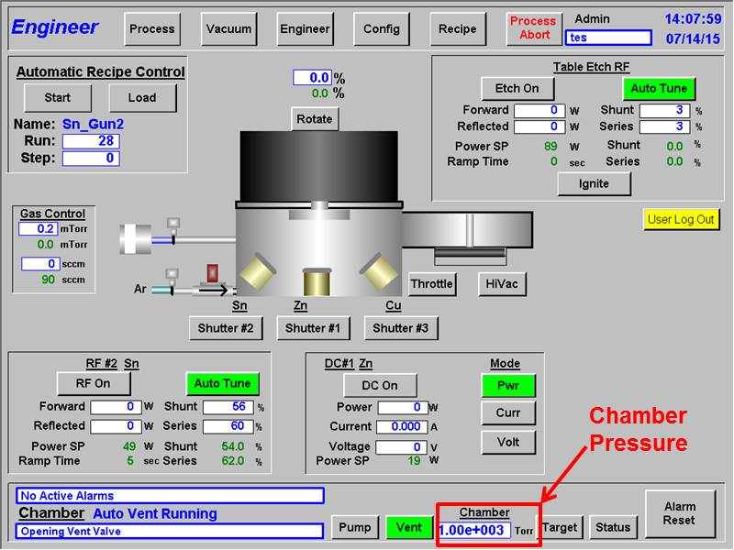
Figure 2: Engineering Tab

5.3.3 Verify that the system is pumping and the chamber pressure at bottom of screen is reading low pressure (Ex: 5x10⁻⁶ Torr).

5.3.4 Press “Vent” button at bottom of screen and it will turn green.

5.3.5 Wait until the chamber reaches atmosphere (You will hear the N2 leaking out).

5.3.6 Lift chamber lid, with the handle, all the way back. (N2 will stop flowing).

5.3.7 Inspect condition of chamber and vacuum any visible flakes of material from walls, sputtering guns, shutters, and tooling.

5.3.8 Replace viewport microscope slides. New slides need to be cleaned with isopropyl alcohol first. Place coated ones into the discard box.

5.4 Changing Targets:

Figure 3: Sputtering Gun locations inside the chamber

5.4.1 Press the grey “Shutter” button for the target you wish to change. Shutter will open and the button will turn green once open.

5.4.2 Remove the threaded anode/dark space shield from the source.

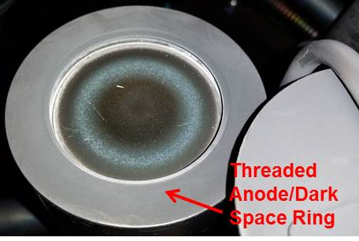
Figure 4: Threaded Anode/Dark Space Ring
5.4.3 Remove the threaded target clamping ring.

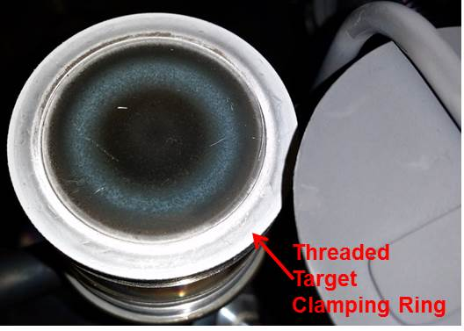
Figure 5: Threaded Target Clamping Ring

5.4.4 If there is a target already in the gun, remove the target and place it in the bag that is labeled with the materials name/abbreviation.

5.4.5 Place the target in the cavity of the cathode body.

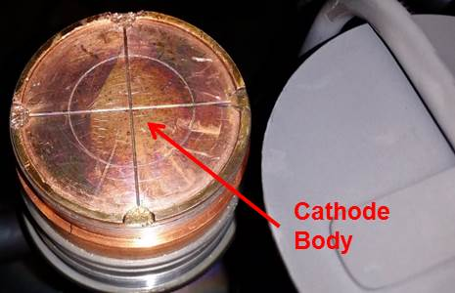
Figure 6: Cathode Body

5.4.6 Thread target clamping ring onto the cathode, target clamp should be tightened to rest on the target and secure the target to the cathode (do not overtighten).

5.4.7 Adjust dark space slip ring until it rests on the step at the base of the copper cathode block and completely shield the threads on the cathode body.

5.4.8 Thread the anode/dark space shield onto the source, place the 1/16” hex/Allen key between the target clamping ring and the anode/dark space shield and tighten the dark space shield down to that level, remove the spacing adjustment tool, adjust the anode shield locking ring until anode shield is tight.

5.4.9 Press the green “Shutter” button for the target you changed. Shutter will close and the button will turn grey once closed.

5.4.10 Once you have mounted your target, it is necessary to change the name of the target in the software. To do this, click on the “Config” tab on the software. The following window should be displayed:
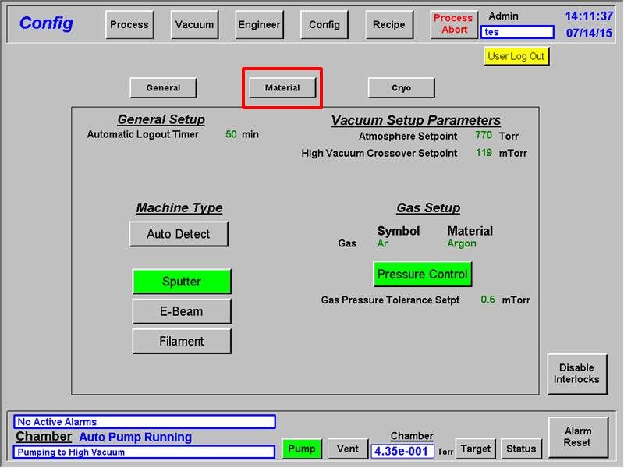
Figure 7: "Config - General" Tab

5.4.11 Next, click on the “Material” button. The following window should be displayed:

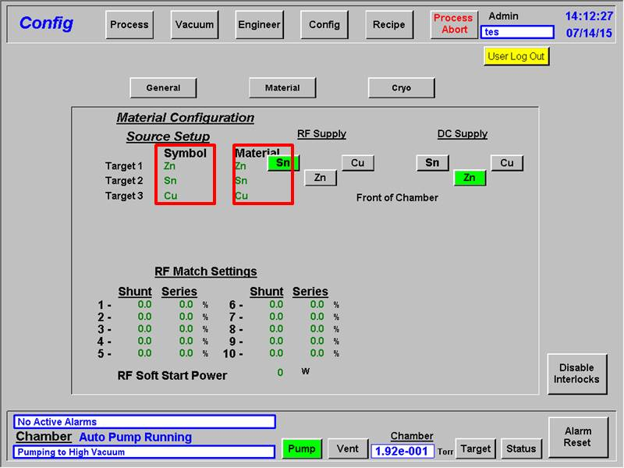
Figure 8: "Config - Material" Tab

5.4.12 Click on the abbreviation of the material that was in the gun that you changed. Change the abbreviation to whichever material you mounted in the gun. Do this for both the “Symbol” and “Material” columns.

5.5 Mounting Samples

5.5.1 If metallizing 4” wafers, carefully mount them into the top of the lid and use the clips to hold into position.

5.5.2 If metallizing smaller pieces than 4”, you will either need to affix your sample using one of the clips on the system or Kapton tape your sample to the sample holder area.

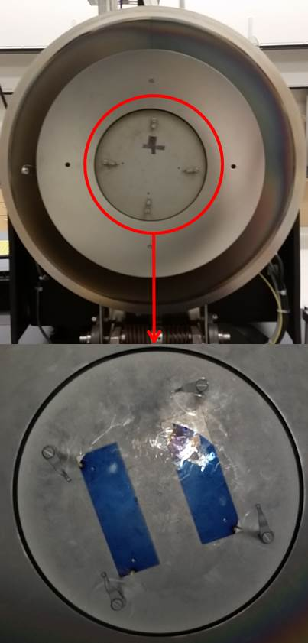
Figure 9: Sample Holder

6.0 Pump Down

6.1 Wipe the chamber O-ring with a lint free cloth and very small amount of isopropyl alcohol. Then dry it with a clean cloth.

6.2 Carefully close the chamber and push the pump button on the bottom of the screen. You will hear the pump start running.

6.3 Hold down on the chamber handle, with pressure, until a noticeable change is heard from the pump.

6.4 Allow system to pump until chamber reaches at least 5 x 10⁻⁶ Torr before starting your recipe.

7.0 Recipes

The 12 standard metals for the system, listed in section 4.1, have pre-set recipes to provide uniform films at common sputtering rates. For most runs, the only parameter you will need to define is the deposition time for your desired thickness.

7.1 Press “Recipe” button. The active recipe name is displayed near the top of the screen. Under the names are the process steps.

For individual metal depositions, go to section 9.0 “Quick Start Run”

A recipe may contain from 1-15 discrete steps to make a complete recipe. To connect multiple step recipes, press the type of action for the step in the order it will take place.
Ex:

7.2 Select first step (1) then press one of the following buttons:

Skip – This step allows you to skip a pre-programmed step and immediately proceeds to the next step in the process.

Figure 10: "Recipe - Skip" Tab

Etch – This step allows you etch the surface of your sample with Argon ions. You can set the power, pressure, and the time for the etching.

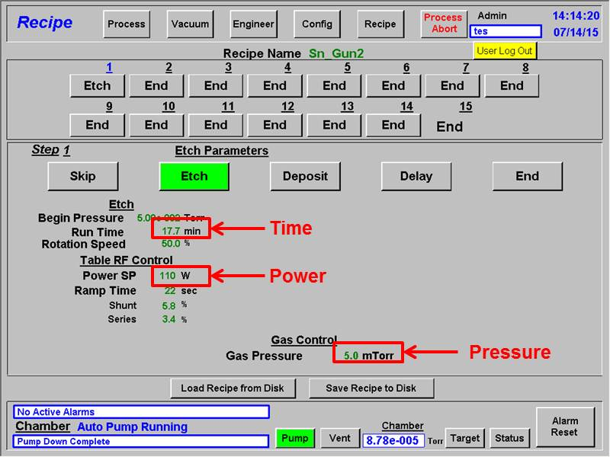
Figure 11: "Recipe - Etch" Tab

Deposit – This step defines parameters for the material, power and film deposition.
To set Deposition parameters;
- Select desired DC Gun and/or RF Gun. If not using one select DC/RF Off.
- Enter the desired “Power SP” in Watts (Maximum power is 1000 W DC or 750 W RF).
- Enter the desired “Pre-Clean Time” in Seconds. Minimum time for pre-clean is 120s.
- Enter the desired “Gas Pressure” in mTorr.
- Enter the desired “Rotation” in a percentage.
- Enter the desired “Run Time” in minutes (This is determined by the total thickness and the rate for the material).

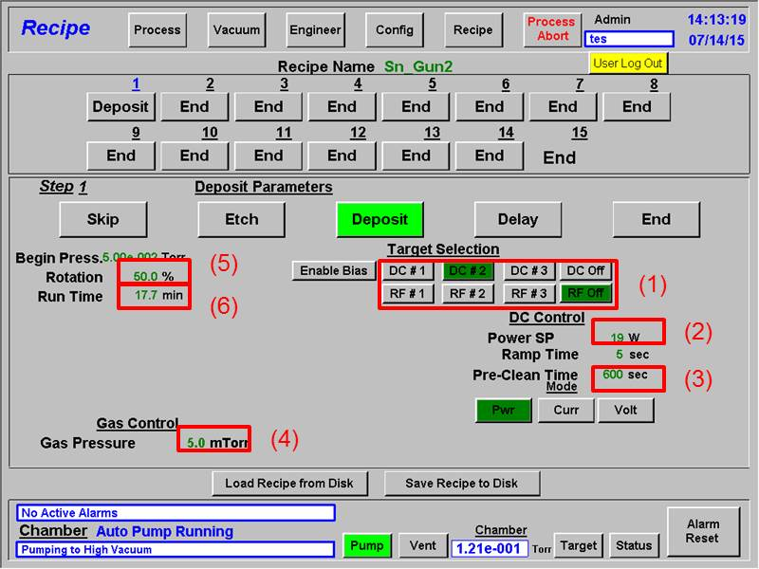
Figure 12: "Recipe - Deposition" Tab

Delay – This step is used mainly to cool down the system between steps. You can change the length of the delay by clicking on the time and enter whatever minute value you would like to delay the deposition.

Note: Always add a delay step between metallization layers

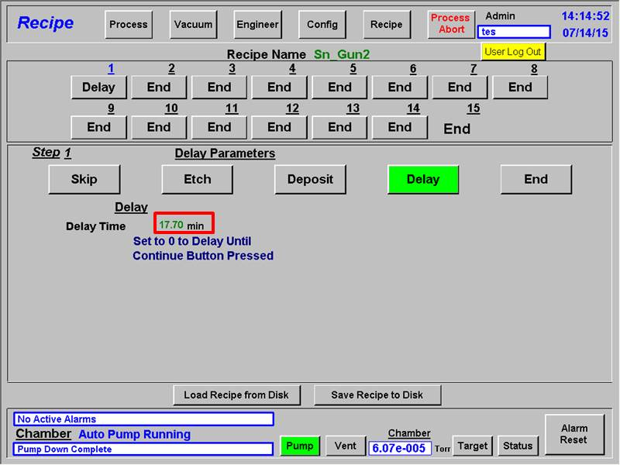
Figure 13: "Recipe - Delay" Tab

End – This step will end the process.

Note: End must be displayed in all steps that are not selected.

Figure 14: "Recipe - End" Tab

8.0 Saving/Retrieving Recipes

NEVER press the “Save Recipe to Disk” button! (This would be editing the standard programs and that is forbidden!)

8.1 To retrieve a saved recipe, press “Load Recipe from Disk”. A drop down window with saved recipes will appear. Select recipe to load, double click on it and press OK. Wait approx. 60 seconds for recipe to load and press OK. The selected recipe will now be active. You may edit the saved recipe by following the steps in Section 7.

9.0 Automatic Process

This section should be used for standalone runs with standard materials used in the Sputtering system.

No recipe parameters are to be saved in this mode!

9.1 Load and pump system per Sections 5.0 and 6.0.

9.2 Press “Recipe” button on top of screen and wait for recipe window to open.

9.3 Press “Load Recipe from Disk” button on bottom of screen.

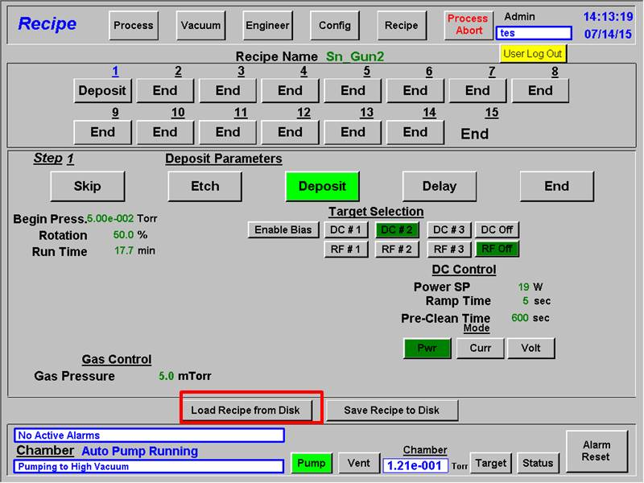
Figure 15: "Recipe" Tab - "Load Recipe from Disk"

9.3.1 A pop-up window will appear. From the Recipe line drop down window, select a pre-set recipe for the material you will run, double click on it and press OK. Wait approx. 60 seconds for recipe to load.

Note: All the materials that already have a rate; have a corresponding recipe saved on the system. The recipe name corresponds to the abbreviation of the material and the sputtering gun that the material was in when determining the rate.

Press OK. The recipe you chose will be displayed at the top of the screen and the process steps will appear. There should be a “Deposit” step in step 1 and all the rest will be “End” steps. Press OK on the pop-up window.

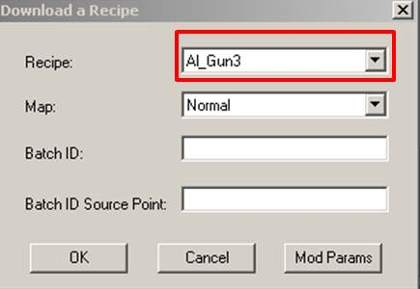
Figure 16: "Download a Recipe"

9.4 Verify that the “Target Selection,” “Power SP,” “Pre-Clean Time,” “Rotation,” and “Gas Pressure” values are correct.

9.5 Press the number next to “Run Time” until a pop-up window opens and you can enter the deposition time, in minutes.

9.6 Press Enter on the keyboard.

9.7 On the top of screen press the “Process” button to enter the Process run screen.

9.8 Verify shutter graphic in center of screen shows a closed shutter. Press “Start” button in upper left corner of screen.

9.9 The system will download the recipe to the controller and start the run. You will see the power increasing to the specified power on the front of the Advanced Energy controller. You may view the plasma from the front viewport of the system (Be sure to wear protective glasses when viewing the plasma). If arcing or flashing is observed, press the “Abort Process” button on the top right of the software window. Then call cleanroom staff.

9.10 When the run is complete: the shutter will close, the controller will turn off, and the system will go back to high vacuum.

9.11 Wait 10 minutes minimum, then vent system to unload per section 5.3 or to run another recipe without venting the chamber, repeat steps 9.2 thru 9.10.

9.12 Once you have finished your deposition/s:

9.12.1 Fill out the logbook that is located on top of the system.

9.12.2 Turn off the “Target Cooling Water.”

9.12.3 Turn off the N2 Vent Gas by turning the valve clockwise on the N2 tank mounted behind the system.

10.0 Manual Process – DC Power Only

This section should be used for runs involving materials that do not have a recipe or have properties that do not allow them to be used with an automatic process.

10.1 Load and pump system per Sections 5.0 and 6.0.

10.2 Press “Engineer” button on top of screen and wait for engineer window to open.

10.3 For processes using only DC Power:

10.3.1 Press the “Target” button on the bottom right hand corner of the screen.

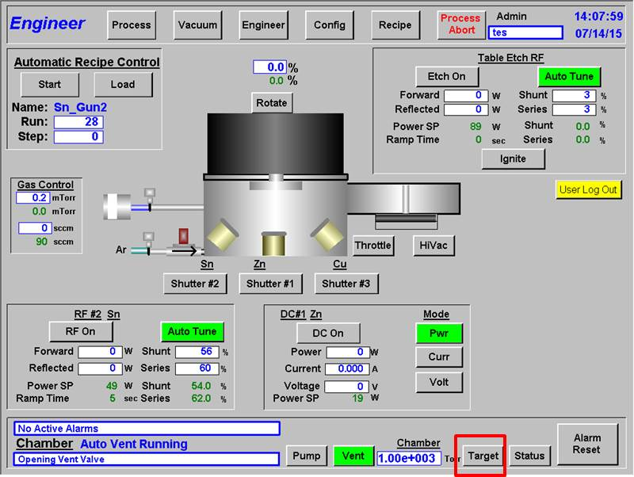
Figure 17: "Engineer Tab" - "Target" Button

10.3.2 A pop-up window should open. On this window, select one of the three targets under “DC Supply” that you wish to use. If the target you wish to use is currently selected under “RF Supply,” first select a different target under “RF Supply” and then select the target you wish to use under “DC Supply.” After you have made your selection, press “Close.”

Figure 18: "Target Selection" - Pop-Up Window

10.3.3 Press the “Throttle” valve in order to enable pressure control.

10.3.4 Press the Argon valve graphic to turn on the flow of Argon gas.

10.3.5 Press the green numbers next to “mTorr” under the “Gas Control” section. And set the pressure (in mTorr) to the value supplied in the “Sputtering Target Rate List” that is with the system. Wait for the pressure to stabilize.

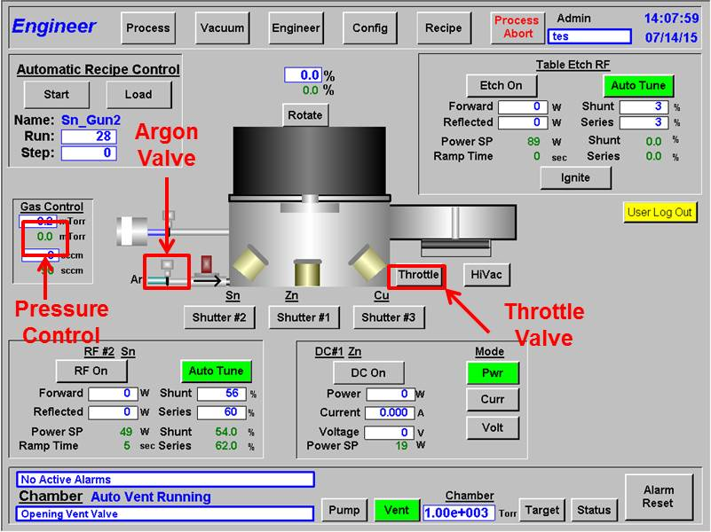
Figure 19: "Engineer Tab" - Manual Process #1 (DC)

10.3.6 In Target Controls box, first, verify that the “Pwr” button, under “Mode,” is selected (highlighted green).

10.3.7 Press the green numbers next to “Power SP” to set the power (in Watts) to the value that is to be used for your deposition. Consult the “Sputtering Target Rate List.”

10.3.8 Press the “DC On” button to turn the power supply on (the button will be highlighted green). Once the power supply has been turned on the power supply will ramp up to the specified power.

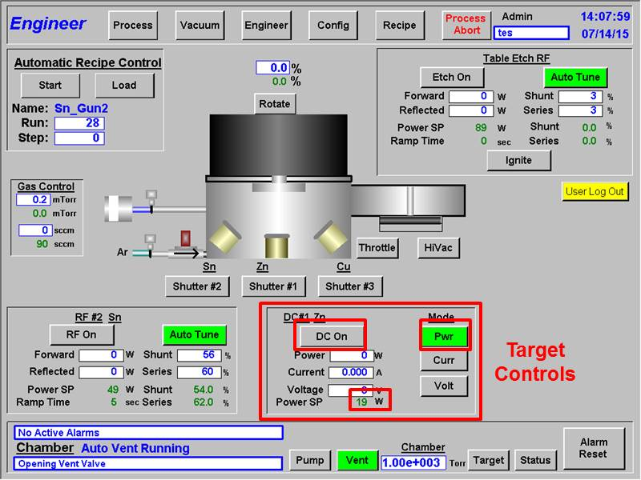
Figure 20: "Engineer Tab" - Manual Process #2 (DC)

10.3.9 Once the power has ramped up, plasma should have been struck. The graphic of the sputtering gun will change color and plasma will be visible through the viewport on the front of the system.

Note: If there is no plasma after the power supply has completely ramped up, you can quickly open and close the shutter by rapidly pressing the “Shutter #x” button twice. If there is still no plasma, quickly press the green highlighted “DC On” button to turn off the power supply to avoid any damage to the target or the system. If this happens, contact staff immediately for assistance.

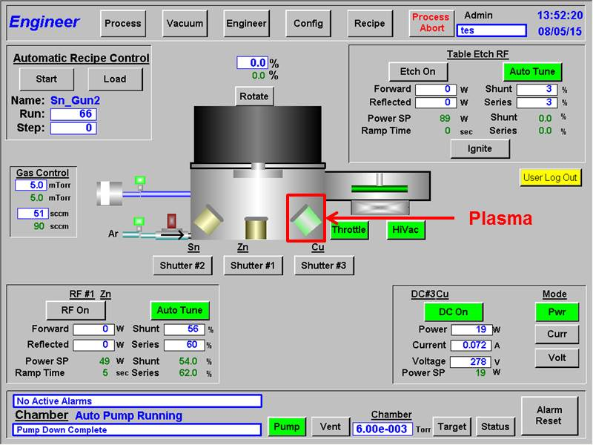
Figure 21: "Engineer Tab" - Manual Process #3 (DC)

10.3.10 Once, the plasma has struck allow at least 2 minutes of pre-clean time before opening the shutter. If the target is a material that oxidizes, increase the pre-clean time to at least 5 minutes.

10.3.11 After the pre-clean time is up, press the “Shutter #x” button (will be highlighted green) and start the stopwatch to keep track of the deposition time. A graphic will show that the shutter is open and that material is being sputtered.

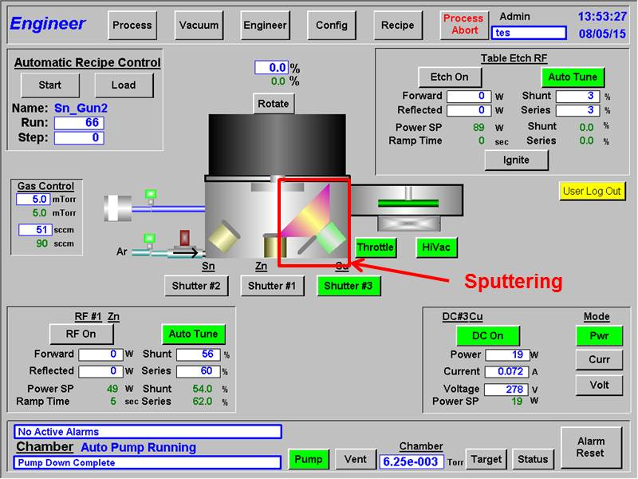
Figure 22: "Engineer Tab" - Manual Process #4 (DC)

10.3.12 Once the material has deposited for the allotted time, press the “Shutter #x” button again (no longer highlighted green) to close the shutter.

10.3.13 Press the highlighted green “DC On” button to turn off the power to the gun.

10.3.14 Press the Argon valve graphic to turn off the flow of Argon gas.

10.3.15 Press the “Throttle” valve in order to disable pressure control.

10.3.16 Wait 10 minutes minimum, then vent system to unload per section 5.3 or to run another recipe without venting the chamber, repeat steps 10.3.1 thru 10.3.13.

10.4 Once you have finished your deposition/s:

10.4.1 Fill out the logbook that is located on top of the system.

10.4.2 Turn off the “Target Cooling Water.”

10.4.3 Turn off the N2 Vent Gas by turning the valve clockwise on the N2 tank mounted behind the system.

11.0 Manual Process – RF Power

Due to a problem with the RF Igniter, it is necessary to first strike a material using DC Power and while that target has plasma you then strike the target that you wish to use with RF Power.

11.1 Load and pump system per Sections 5.0 and 6.0.

11.2 Press “Engineer” button on top of screen and wait for engineer window to open.

11.3 For process using RF Power:

11.3.1 Press the “Target” button on the bottom right hand corner of the screen.

Figure 23: "Engineer Tab" - "Target" Button

11.3.2 A pop-up window should open. On this window, select one of the three targets under “RF Supply” that you wish to use. If the target you wish to use is currently selected under “DC Supply,” first select a different target under “DC Supply” and then select the target you wish to use under “RF Supply.” After you have made your selection, press “Close.”

Figure 24: "Target Selection" - Pop-Up Window

11.3.3 Press the “Throttle” valve in order to enable pressure control.

11.3.4 Press the Argon valve graphic to turn on the flow of Argon gas.

11.3.5 Press the green numbers next to “mTorr” under the “Gas Control” section. And set the pressure (in mTorr) to the value supplied in the “Sputtering Target Rate List” that is with the system. Wait for the pressure to stabilize.

Figure 25: "Engineer Tab" - Manual Process #1 (RF)

11.3.6 Follow the steps in sections 10.3.6 to 10.3.9 to first strike a target using DC Power. Once a target has been struck using DC Power, it is now possible to strike a target using RF Power.

11.3.7 In the Target Controls box, verify that the “Auto Tune” button is selected (highlighted green).

11.3.8 Press the green numbers next to “Power SP” to set the power (in Watts) to the value that is to be used for your deposition. Consult the “Sputtering Target Rate List.”

11.3.9 Press the green numbers next to “Ramp Time” to set the time (in Seconds) that it will take for the power supply to ramp up to the power set by the “Power SP.” This time should be 5 seconds per every 50 W.

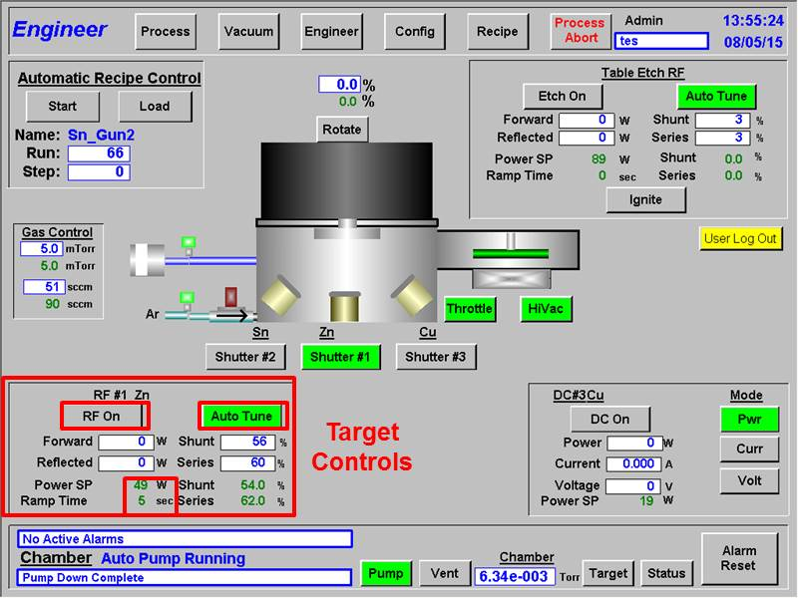
Figure 26: "Engineer Tab" - Manual Process #2 (RF)

11.3.10 Press the “RF On” button to turn the power supply on (the button will be highlighted green). Once the power supply has been turned on the power supply will ramp up to the specified value.

11.3.11 Once the power has ramped up, plasma should have been struck. The graphic of the sputtering gun will change color and plasma will be visible through the viewport on the front of the system. The graphics for both guns should now have turned green.

Note: If there is no plasma after the power supply has completely ramped up, you can quickly open and close the shutter by rapidly pressing the “Shutter #x” button twice. If there is still no plasma, quickly press the green highlighted “RF On” button to turn off the power supply to avoid any damage to the target or the system. If this happens, contact staff immediately for assistance.

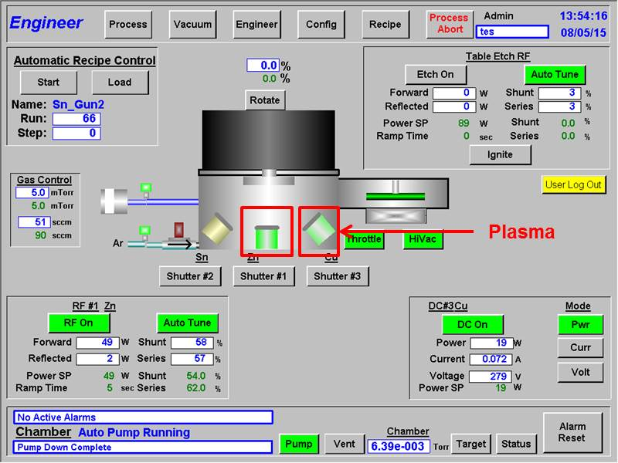
Figure 27: "Engineer Tab" - Manual Process #3 (RF)

11.3.12 Now that the material has RF plasma, turn off the target, with DC plasma, by pressing the “DC On” button (no longer highlighted green).

11.3.13 Once, the plasma has struck allow at least 2 minutes of pre-clean time before opening the shutter. If the target is a material that oxidizes, increase the pre-clean time to at least 5 minutes.

11.3.14 After the pre-clean time is up, press the “Shutter #x” button (will be highlighted green) and start the stopwatch to keep track of the deposition time. A graphic will show that the shutter is open and that material is being sputtered.

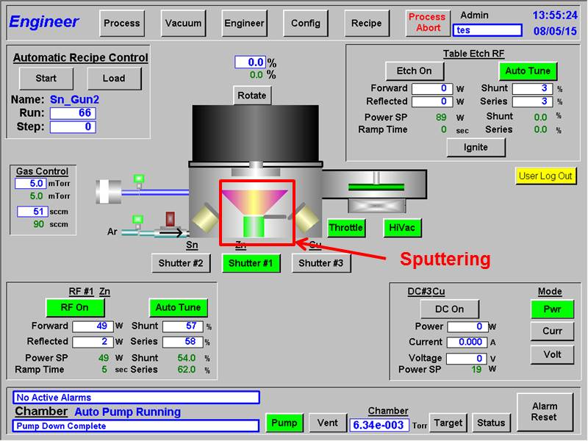
Figure 28: "Engineer Tab" - Manual Process #4

11.3.15 Once the material has deposited for the allotted time, press the “Shutter #x” button again (no longer highlighted green) to close the shutter.

11.3.16 Press the highlighted green “RF On” button to turn off the power to the gun.

11.3.17 Press the Argon valve graphic to turn off the flow of Argon gas.

11.3.18 Press the “Throttle” valve in order to disable pressure control.

10.3.16 Wait 10 minutes minimum, then vent system to unload per section 5.3 or to run another recipe without venting the chamber, repeat steps 10.3.1 thru 10.3.13 for a deposition using only DC power or 11.3.1 thru 11.3.16 for a deposition using RF power.

11.4 Once you have finished your deposition/s:

11.4.1 Fill out the logbook that is located on top of the system.

11.4.2 Turn off the “Target Cooling Water.”

11.4.3 Turn off the N2 Vent Gas by turning the valve clockwise on the N2 tank mounted behind the system.

